**EXCEPTION HANDLING**

Throwable is a class and it is at the top of the hierarchy. It contains sub-classes i.e Exception and Error.

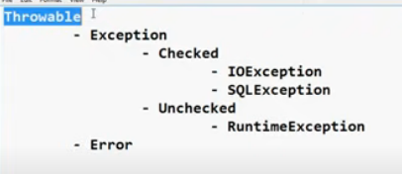

Exception

1. It can be handled by programmers
2. Examples – Dividing by zero, not giving the input when needed etc.
3. They are two types :

* Checked(Compile time exceptions, usually indicated by IDE) - > Examples – IOException, SQLException
* Unchecked(Runtime exceptions) - > Examples – ArrayIndexOutOfBounds

Error

1. It cannot be handled.
2. Examples – OutofMemoryError, Memory leakge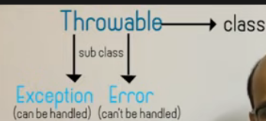

There are two types of statements:

1. Normal 🡪 int i=10;
2. Critical 🡪 int i = k/j; here j might be zero

In the case of critical statements, these statements have to be written to try and catch block

try{

int i = k/j;

}catch{

//some code

}

try will throw the exception and catch block will catch the exception. There may be multiple catch for a single try block.

Always follow the hierarchy of exceptions. Use of Exception class in catch block should be at last, since it can handle all types of Exception.

Exception class is the parent class of all the exceptions(like ArrayIndexOutOfBoundsException, IOException, ArithmeticException)

**Finally block**

Code in finally block is executed in every condition, irrespective of exception occurred or not.

try{

}catch(){

}

finally{

}

We can also write resources in try block. In the below-mentioned case, we don’t have to create a catch or finally block. Resource exception is handled and it is closed automatically.

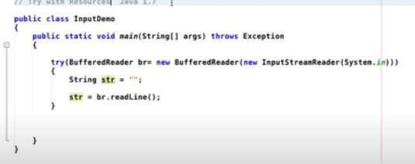

**Throws keyword**

throws keyword suppresses the exception in java.It does not handle the error,it just suppresses the error.

It just indicates that this method/statement may throw an exception. It is used for compile-time exception / checked exception. It can be used to throw multiple exceptions.

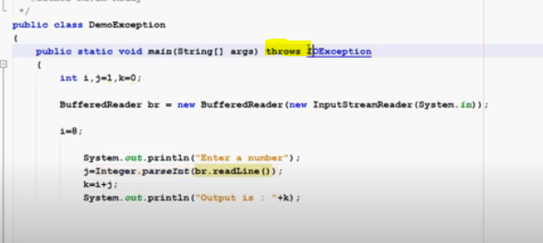

**throw keyword**

It is used to throw the exception and the catch block catches the exception, i.e handles this exception.

It is used to create the exception object manually. It is used for runtime exception/unchecked exception.

It can throw only single exception at a time. We cannot write any statements after throw keyword, it will give error as unreachable statement.

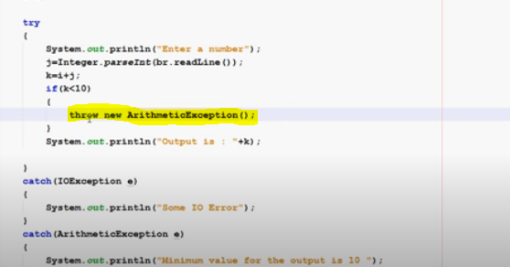

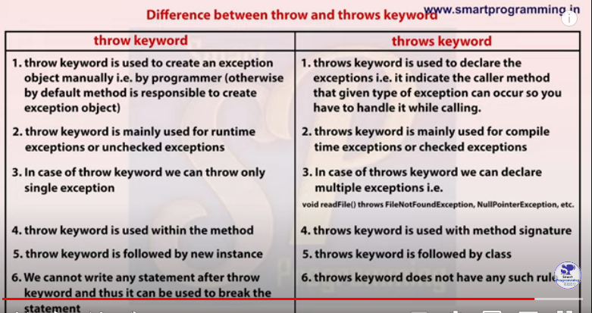

**Custom Exception**

We can also create our own exception class by extending the Exception class and creating a constructor and calling the constructor of the parent class.

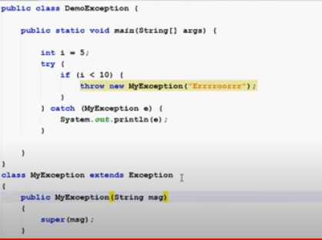

**MULTITHREADING**

Thread is a unit of a process. It is an inbuilt class of java

For example,

1. if you are using ms word, ms word is a process, typing is a sub-process (thread), and spelling check is a sub-process (thread). By default in every java application, there is one thread i.e main thread.
2. In Gaming, if you are running and your partner is also running, so different things are happening simultaneously i.e multiple threads are running at the same time.

We don’t have to call the run method, we just have to start the thread. For example

Thread t = new Thread();

t.start();

There are two ways of creating a thread:

1. By extending thread class

Whenever we create a thread we have to override run method.

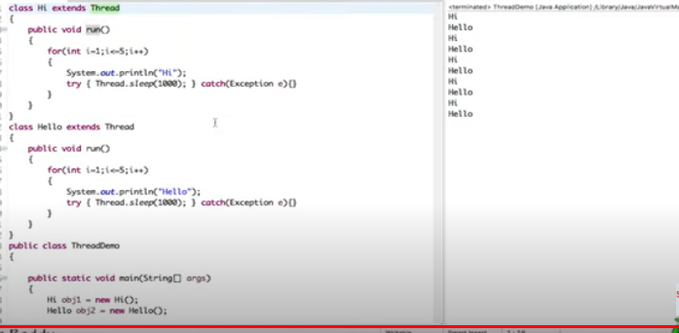

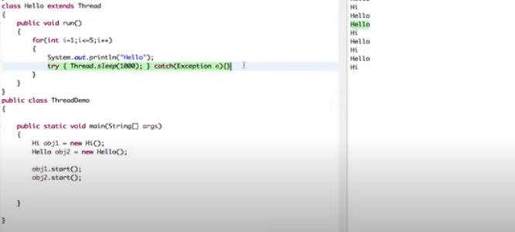

1. By implementing runnable interface.

Runnable interface contains only one method i.e run

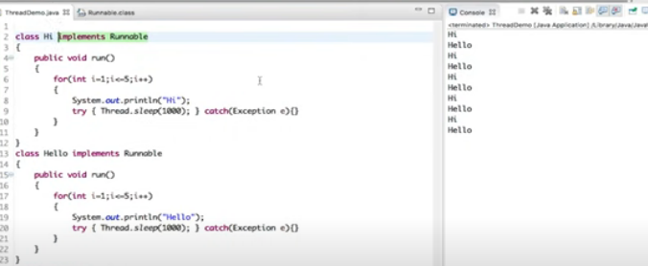

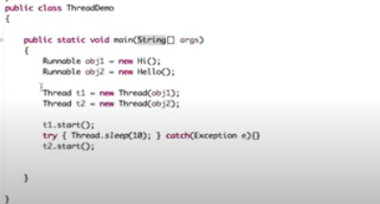

Same code can be written using lambda expression and anonymous inner classes

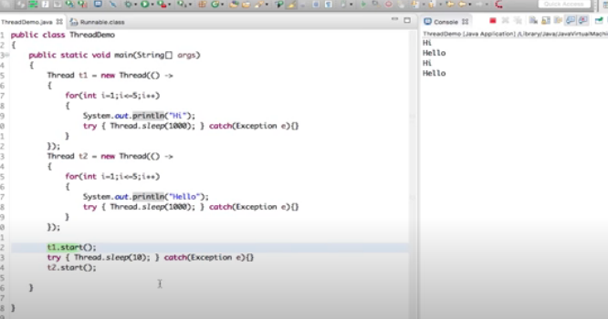

There are 4 ways to specify what code a thread should run:

1. Create a class that extends the Thread class and overrides the run method

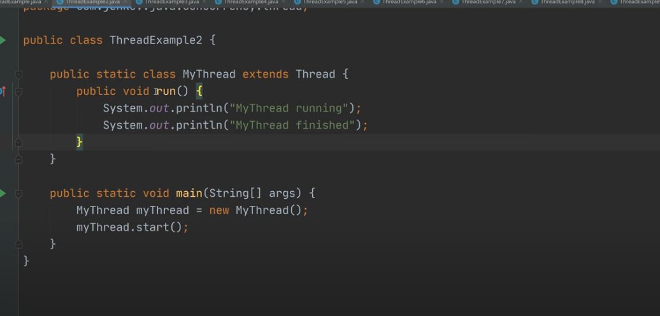

1. Create a class that implements the runnable interface(ie override run method) and pass this class instance to Thread class constructor.

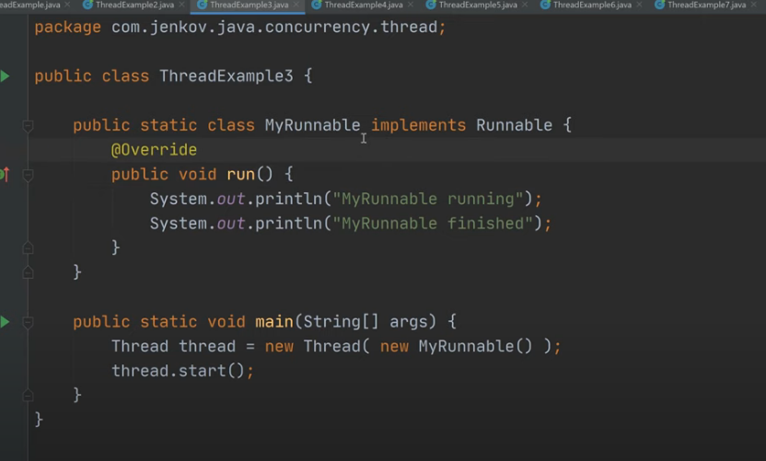

1. Same as method 2 but with anonymous class

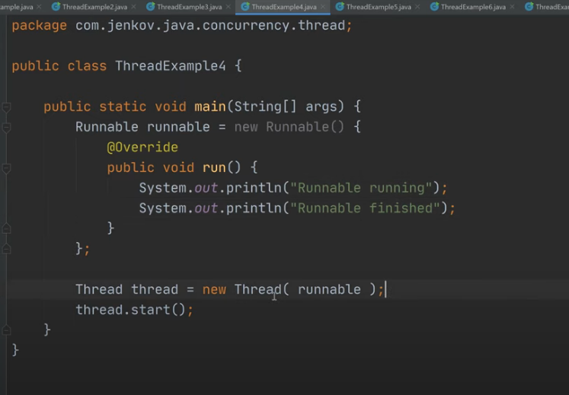

1. Same as method 2 but with lambda expression

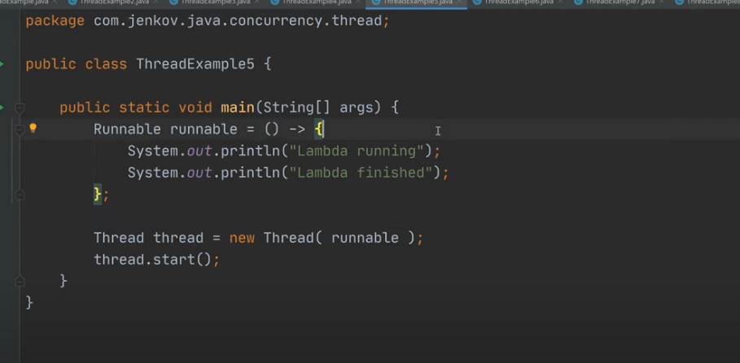

We can also pass the thread name in the constructor of Thread class and it can be accessed by Thread.currentThread().getName().

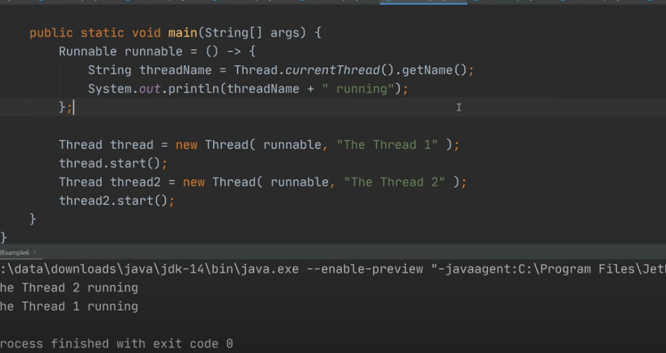

Stopping a thread

We can use Thread.stop() to stop a thread but it is generally not recommended, as it may give some unexpected results.

Daemon Thread

https://www.baeldung.com/java-daemon-thread#:~:text=Uses%20of%20Daemon%20Threads,JVM%20threads%20are%20daemon%20threads.

Thread uses stack memory, a new stack is created for every thread.

When we pass the runnable instance to the thread class constructor, the run method of that particular instance is executed. It actually executes the run method of the thread class(as displayed below), when we pass the runnable instance to it, it sets that particular runnable instance to target and then target.run() method is executed.

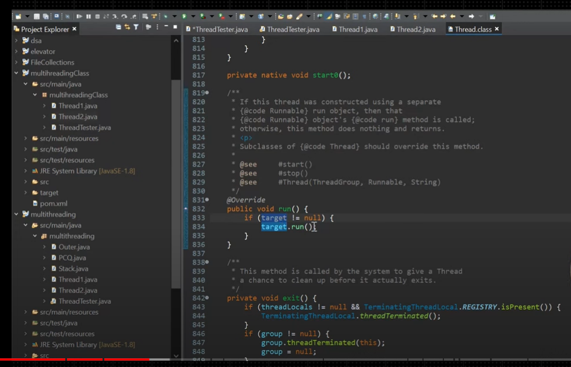

**Join method**

When the join() method is invoked, the current thread stops its execution and the thread goes into the wait state. The current thread remains in the wait state until the thread on which the join() method is invoked has achieved its dead state.

**Priority in Thread**

We can set thread priority by using setPriority(number) , where the number can be between 1 and 10. 1 is the least priority and 10 is the highest priority. By default, the priority of the thread is 5.

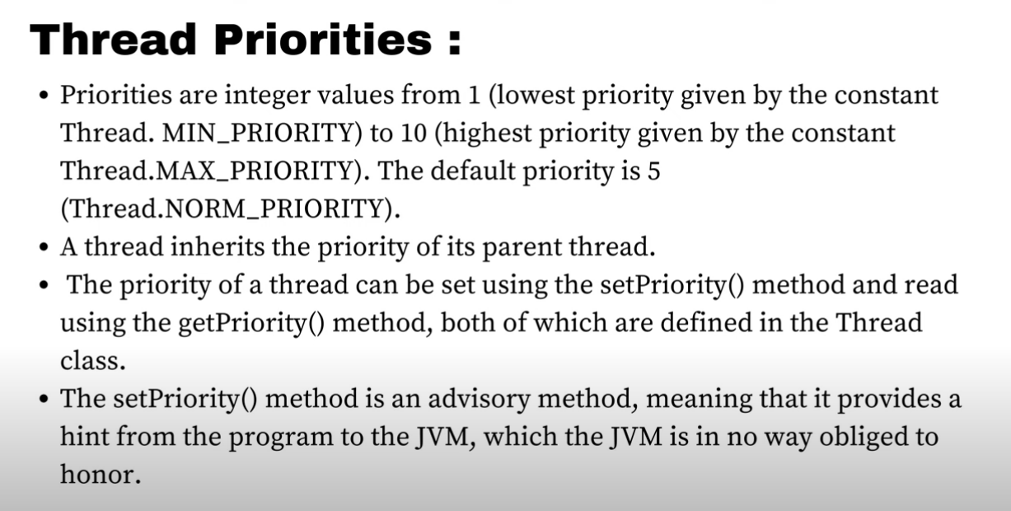

**synchronized** keyword

when we declare any method as synchronized, it is thread-safe. i.e this method will be used by one thread at a time. If any other Thread is going to use this method, it will wait for the first thread to complete it’s execution.

For example, there is a method that increases it’s count by one every time a thread calls this method, so if two threads are calling the same method, the value of the count may be uncertain i.e it does give the desired result.

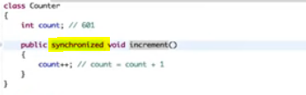

Wait, notify and notifyAll -> These methods are already defined in object class we don’t have to create our own implementation.

**Wait() and notify()**

These methods are used in inter-thread communication.The **wait()** method causes the current thread to wait until another thread invokes the **notify()**or **notifyAll()**methods for that object. The **notify()** method **wakes up a single thread** that is waiting on that object’s monitor. The **notifyAll()** method **wakes up all threads** that are waiting on that object’s monitor. A thread waits on an object’s monitor by calling one of the **wait()**methods.

Whenever a thread is awakened by the other thread, it does not directly goes to runnable state it has to acquire a lock on the object then only it moves to runnable state.

Yield()

This method changes to the state of thread from running to ready to run state. It is an advice to JVM to give chance to other threads to perform the operation, it does not necessarily perform the same operation.

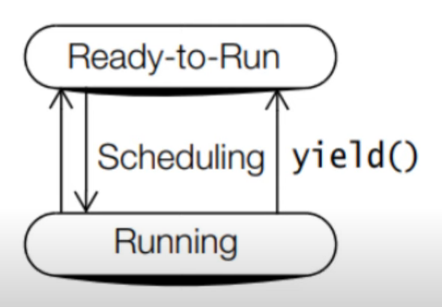

Sleep() method

Thread suspends it’s operation when it is sleeping. It restarts it’s execution in 2 cases:

1. When the thread sleeping time elapsed
2. When the thread is interrupted by some other thread while it is sleeping, in this case it throws interrupted exception. that is why we handle this exception while we use sleep method. It won’t directly throw it waits for execution, and when it gets executed then it throws.

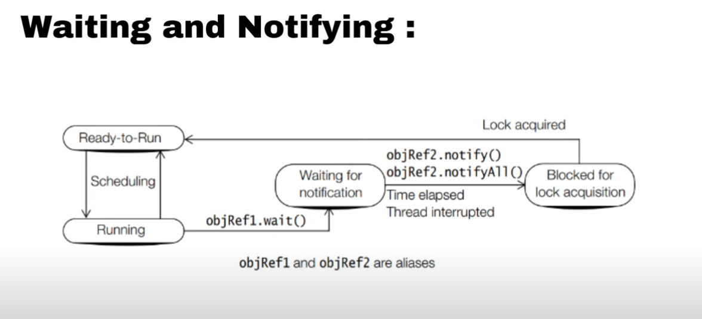

When thread is sleeping it does not relinquishes a lock , but when a thread is waiting it let goes the lock.It relinquishes on lock.



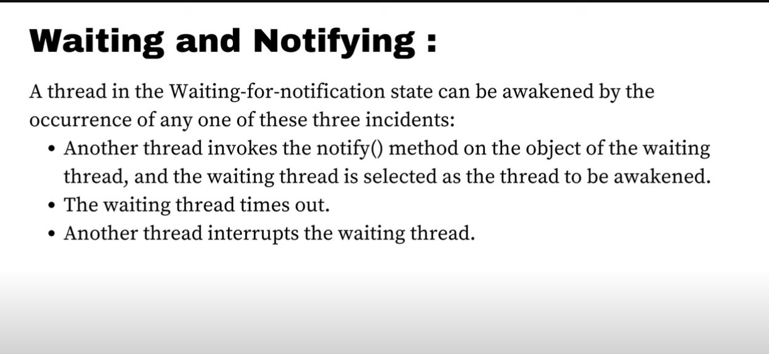

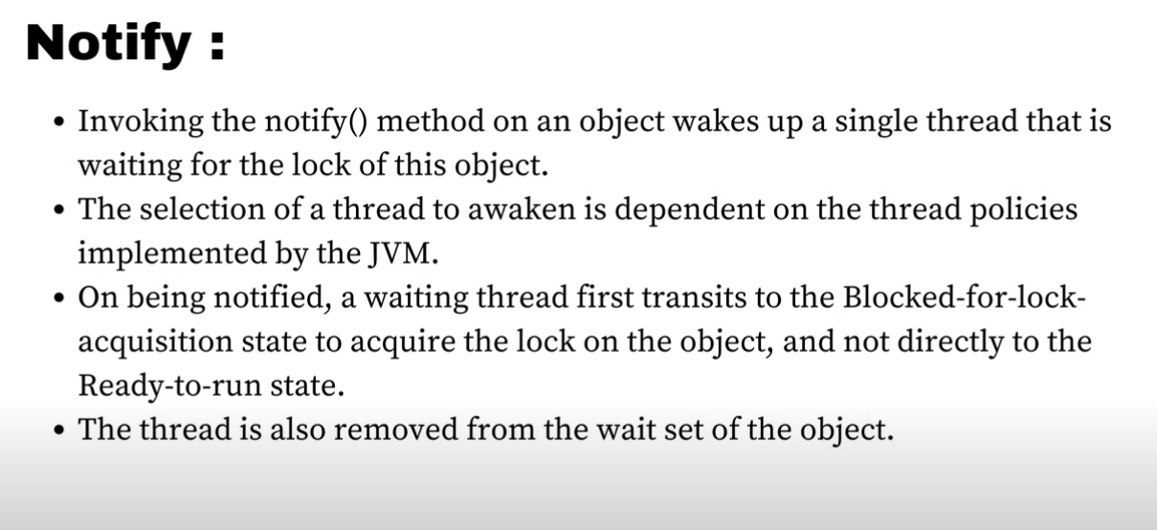

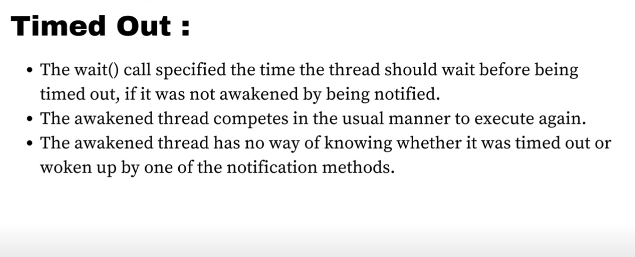

Thread Pool

<https://www.geeksforgeeks.org/thread-pools-java/>

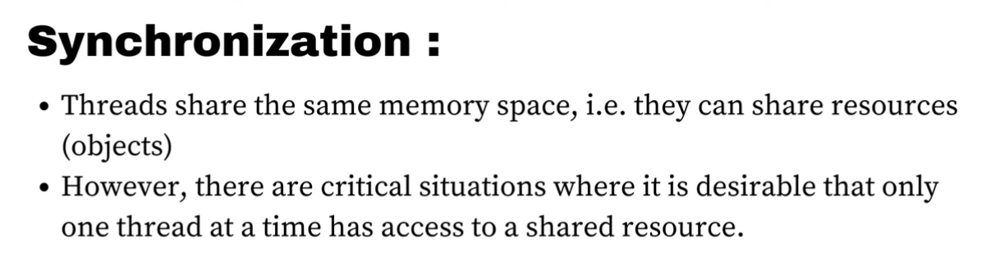

When we declare a method as synchronized,

In case of non-static method, compiler converts that code to synchronize block by passing current object as argument.(using this keyword).

In case of static method, there is no single object as it is shared with multiple objects so it uses CLASS_NAME.class as argument to the synchronized block.

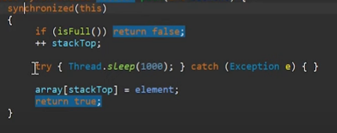

The code in the synchronized block can only be accessed by the thread which is currently accessing that object.

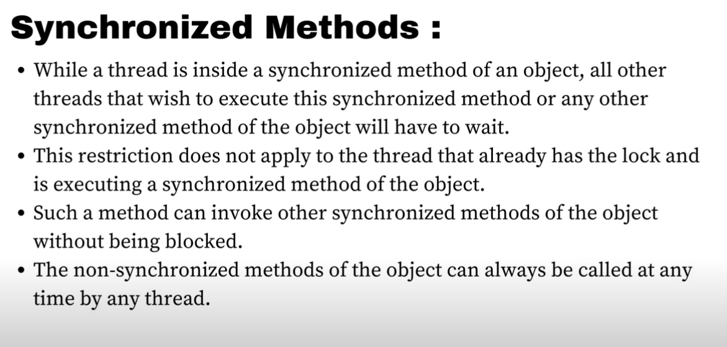

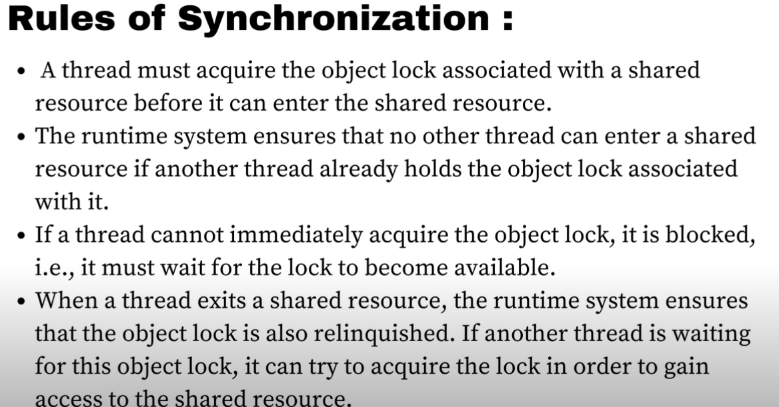

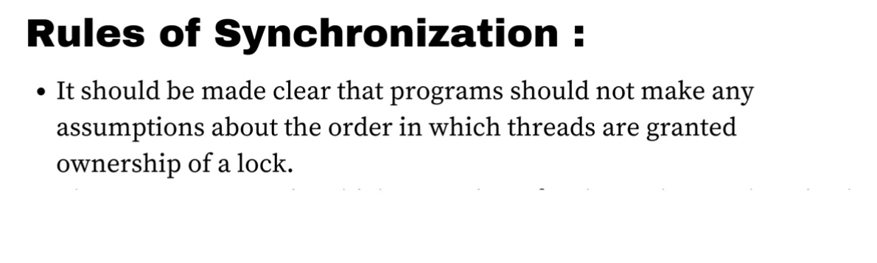

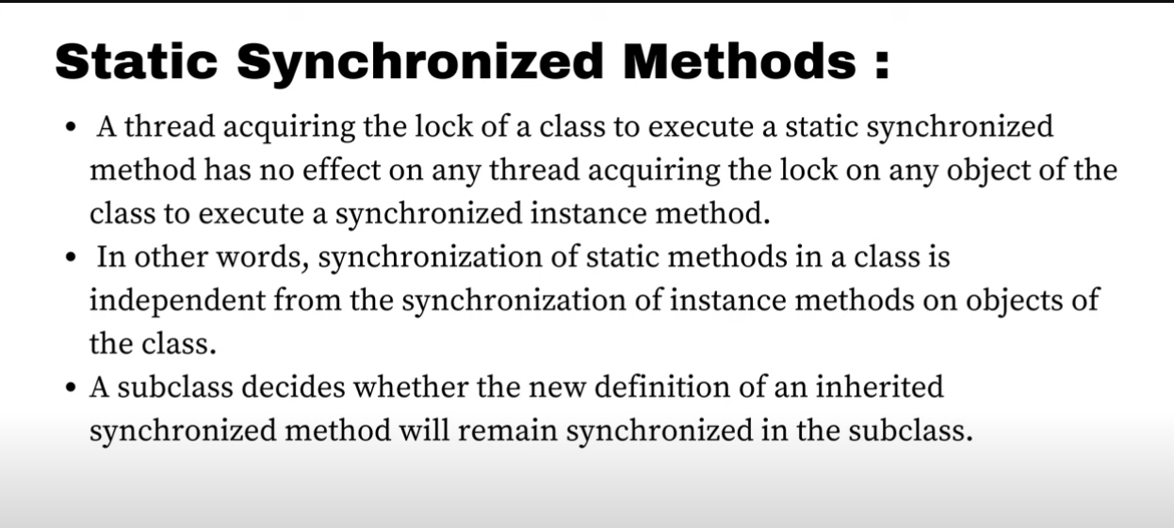

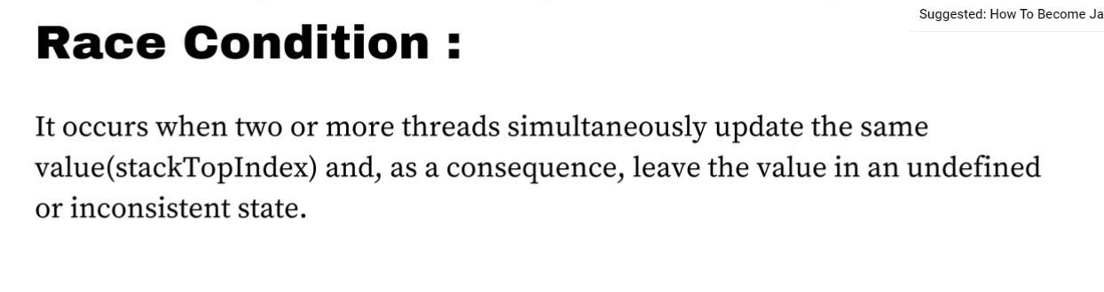

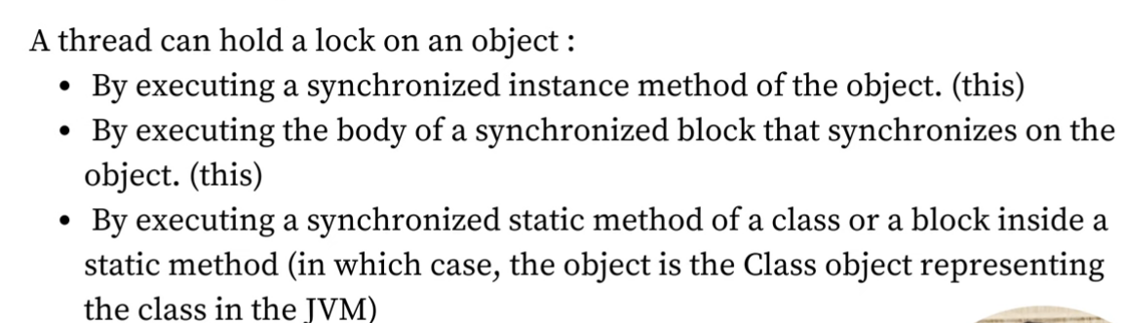

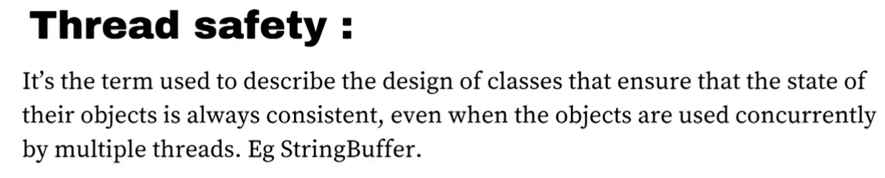

Volatile keyword

<https://www.javatpoint.com/volatile-keyword-in-java#:~:text=Volatile%20keyword%20is%20used%20to,same%20time%20without%20any%20problem>.

Deadlock

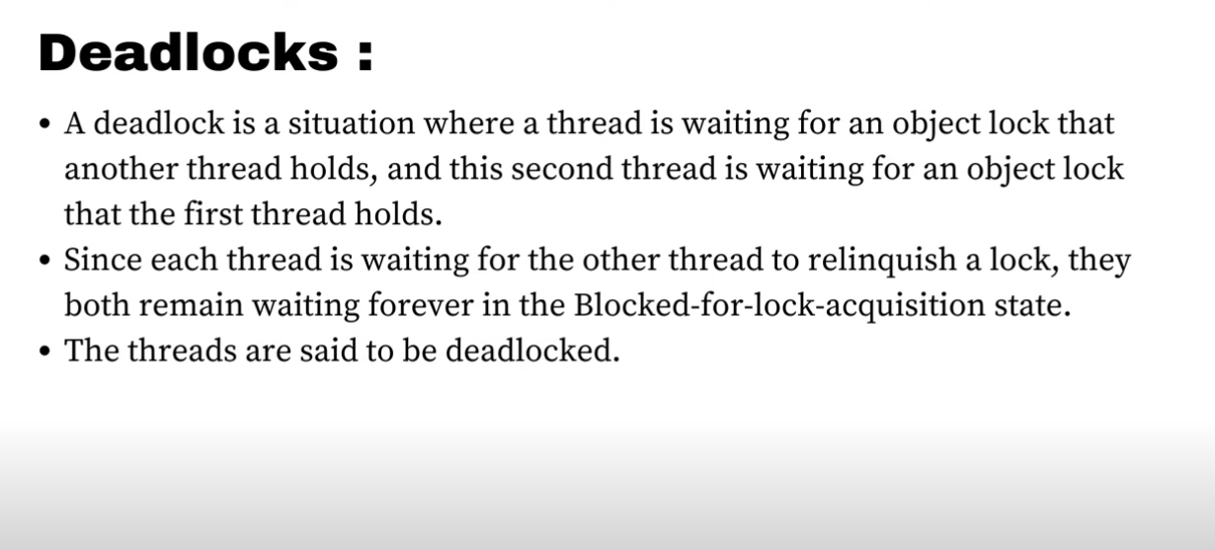

Sample code for deadlock

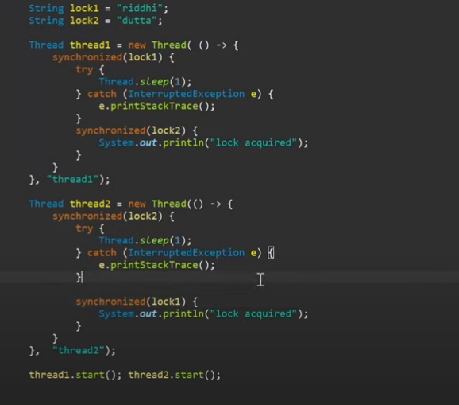

**Enum**

The **Enum in Java** is a data type that contains a fixed set of constants.

It can be used for days of the week (SUNDAY, MONDAY, TUESDAY, WEDNESDAY, THURSDAY, FRIDAY, and SATURDAY) , directions (NORTH, SOUTH, EAST, and WEST), season (SPRING, SUMMER, WINTER, and AUTUMN or FALL), colors (RED, YELLOW, BLUE, GREEN, WHITE, and BLACK) etc. According to the Java naming conventions, we should have all constants in capital letters. So, we have enum constants in capital letters.

Java Enums can be thought of as classes that have a fixed set of constants (a variable that does not change). The Java enum constants are static and final implicitly. It is available since JDK 1.5.

* **Enum improves type safety**
* **Enum can be easily used in switch**
* **Enum can be traversed**
* **Enum can have fields, constructors, and methods**
* **Enum may implement many interfaces but cannot extend any class because it internally extends Enum class**

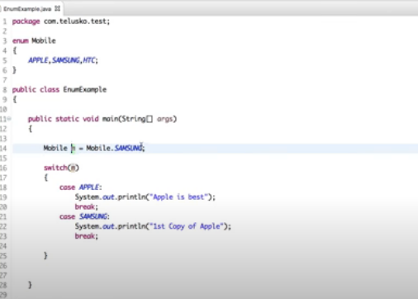

When we create enums we actually create object of it for example the highlighted things happens in the backend.

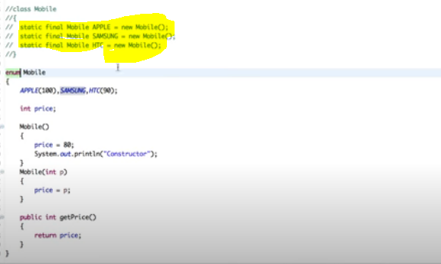

Every enum extends a class called Enum. We can also print the ordinal in enums which means sequence (analogous to the index of the array). In the above example, the ordinal of APPLE would be 0, for Samsung it would be 1.

**Enums can also implement an interface.**

**Java is a type-safe language i.e whenever we declare a variable , it’s type should be specified at compile time.**

**Collection Framework**

Collection is interface. Collections is a class. Generic works only with classes(i.e wrapper classes)

For example – List<Integer> list = new List<>();

We cannot implement it like this -🡪 List<int> list = new List<>();

Example – using your own class(user-defined class)

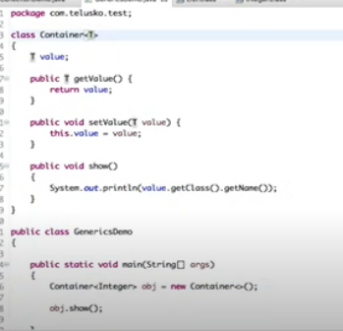

To access value from the collection, there are 3 ways:

1. Iterator

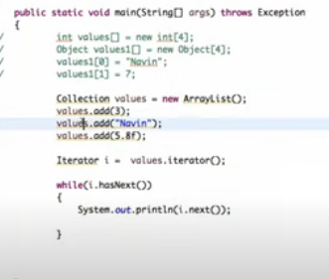

1. Enhanced For loop

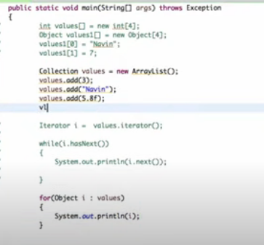

1. ForEach

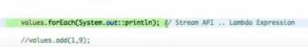

**Difference between ArrayList and Vector**

1. ArrayList dynamically increases the memory by 50%, but the vector increases it by 100%.

In order to save memory, ArrayList is recommended

1. ArrayList is not threadSafe, but vector is thread-safe. Just because of this ArrayList is fast as compared to vector.

**Difference between ArrayList and LinkedList**

1. In ArrayList when an element is added in between, the whole list needs to be adjusted(similar in the case of removal) which does not happen in case of a Linked List.

**Comparator Interface**

This interface contains compare method. This interface is used to compare two objects.

For example, we need to sort elements. Then we need to create an instance of this interface and override the compare method in accordance with sorting logic.

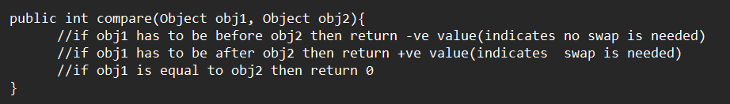

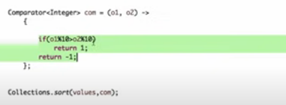

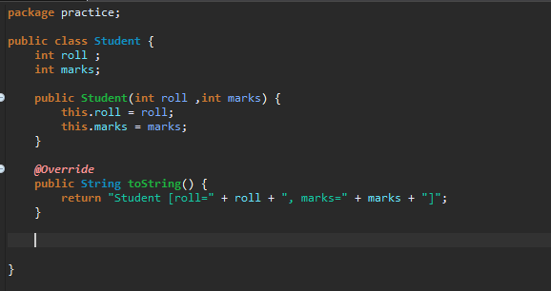

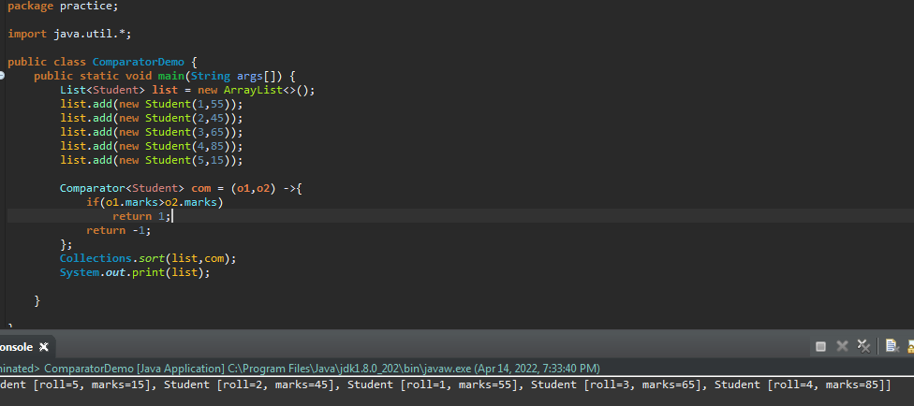

**Comparable Interface**

In this interface, we have compareTo function which needs to be overwritten by a class that implements the comparable interface.(overwritten logic is similar to compare function of the comparator).

Comparable interface compares current object with the passes object.

If we are using custom class, then it is better to use comparable because Collections.sort() method does not have to put extra effort to sort objects according to particular order.

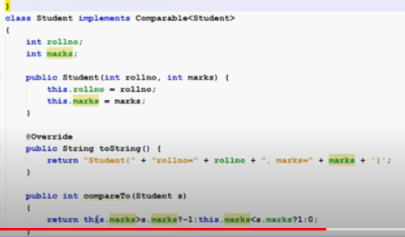

**Set Interface**

Set interface is implemented by two classes i.e Hashset and TreeSet. Set only supports distinct elements. It does not have duplicate elements.

If we create an instance of set and add values in it ,for example

Set<Integer> set = new HashSet<Integer>()

set.add(5);

set.add(6);

set.add(9);

set.add(5);

The add() returns a Boolean value, in the above example, the first three add will return true, but the last add would return false since 5 is already added to the set.

While fetching values from HashSet, it does not return values in the same order in which the values were stored, because of hashing.

**TreeSet returns the value in a sorted format.**

**Map Interface**

This interface takes two generic values i.e key value pairs. It is implemented by four classes HashMap ,LinkedHashMap, TreeHashMap and HashTable. Hashtable is thread-safe. LinkedHashMap is used to maintain the order in which values are fetched.

In order to store data based on the sorted order of keys(ascending order), TreeMap is used.

Map also contains entry interface, which contains a single entry.

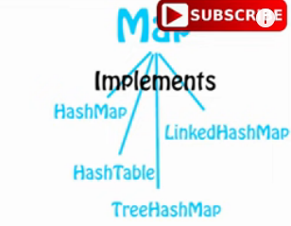

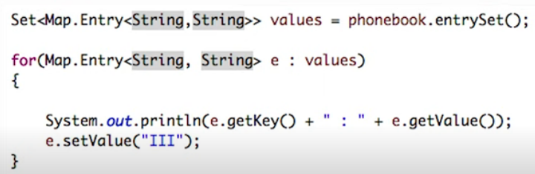

entrySet() return a single entry.

In the below example, while fetching map we don’t get result in the required order, similar concept of hashcode/hashing is used here.

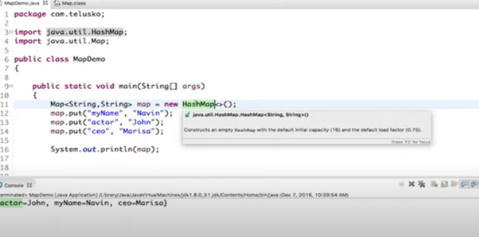

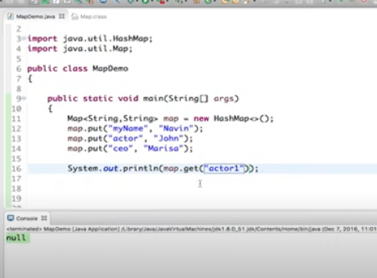

If the key is not available then it will not give exception, it will return null.

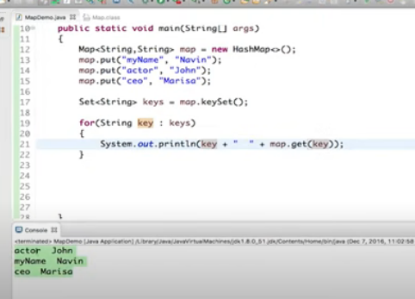

In order to iterate over the map , we can make use of keyset(), which will return set of keys.

While inserting values in the map, if we repeat keys then the value for that particular key would be updated, since we don’t have duplicate keys in map.

Example –

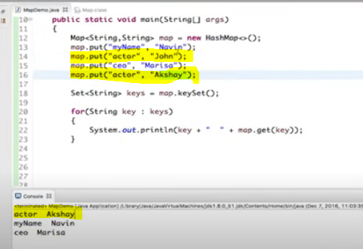

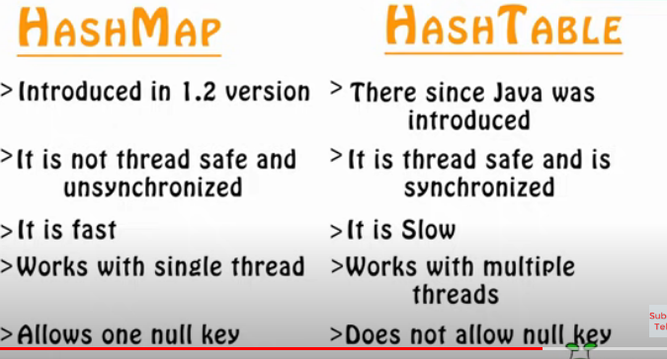

**Java 8 Features**

Features introduced in java 8:

1. Functional programming
2. Lambda expression
3. Stream API.

Interfaces are by default public abstract in java.

Stream() is introduced in java 8 in the List interface.

In java 8 we can define methods inside the interface, here, methods will have access modifiers as default.

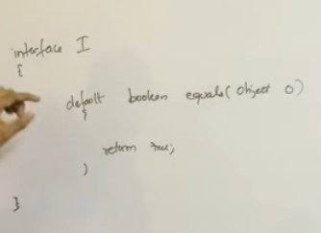

We can also create static methods in interface.

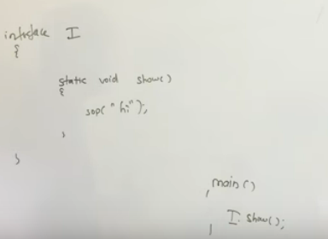

**forEach method**

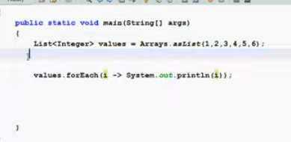

**Implementation of forEach method**

It uses Consumer interface

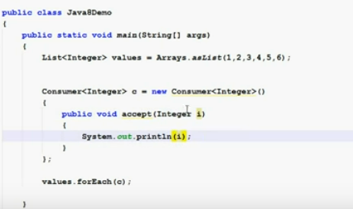

If your interface has only one method then we can use lambda expression instead of creating object and implementing their methods.

Method Reference can be referenced by :: this symbol

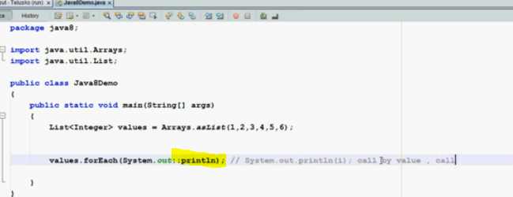

parallelStream() method creates multiple threads and executes the operation simultaneously.

LAMBDA EXPRESSIONS

Lambda expression was added to Java very lately. It was already introduced in many other languages.

It is an anonymous function without any name, modifier, or return type.

Normal method

public void m1(){

Sopln(“Hello”);

}

Lambda expression

() -> {

Sopln(“Hello”);

}

Features

1. To enable functional programming in java
2. Write more readable, efficient, and maintainable code.
3. To enable parallel processing

(int a, int b) -> {Sopln(a +b) }

The compiler is able to guess the type of values (this is called type inference) so the type in lambda expression can be removed.

(a,b) -> { Sopln(a +b) }

If only 1 line is present in lambda expression, curly braces can be removed.

If lambda expression contains 1 parameter then parenthesis can also be removed.

**Normal method**

public int getLength(String s){

return s.length();

}

**Equivalent lambda expression**

s -> s.length() ( no need to write return method)

FUNCTIONAL INTERFACE

It is an interface that contains only one abstract method, it may contain any number of default or static methods. Example – Runnable, Callable etc.

We use @FunctionalInterface annotation on top of the interface to restrict that interface from adding more than 1 abstract interface.

If we declare any interface as @FunctionalInterface it should compulsorily contain 1 abstract method. Else it will give compile time errors.

**Inheritance with a functional interface**

1. If a child interface (declared as FunctionalInterface) extends another functional interface and does not contain any abstract method, then it is a valid scenario. If a child has any other abstract method it will result in compile time error.
2. Normal interface can also extend functional interface and it may contain multiple abstract methods.

**Normal Method to use interface**

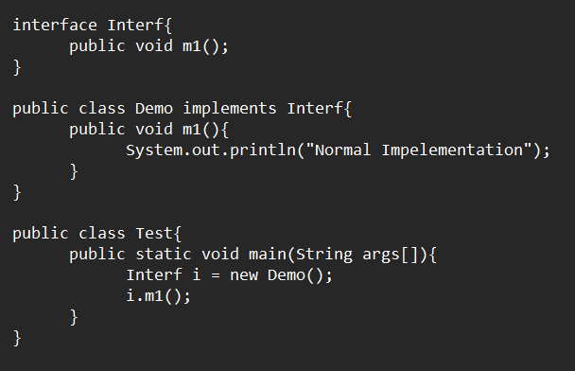

**The above code can be used using the lambda expression**

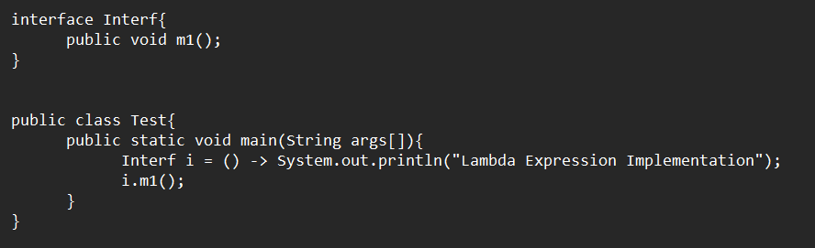

**Why functional interface should contain only one abstract method?**

If we use two abstract method for functional interface then the compiler will get confused regarding the type of data as mentioned in the below example. It will give incompatible types error : interface is not a functional interface.

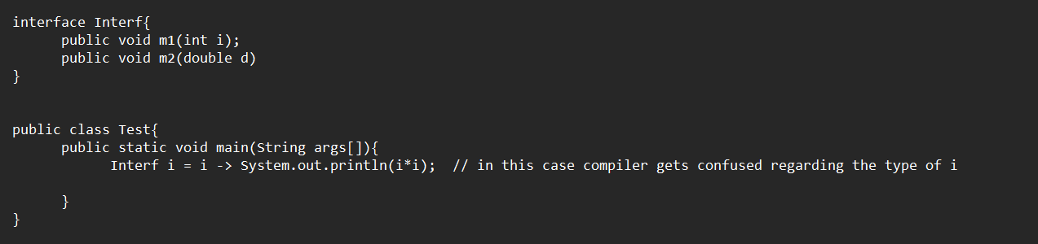

There are many predefined functional interfaces in java :

1. Predicate - It contains one Boolean valued function, function which returns Boolean value.

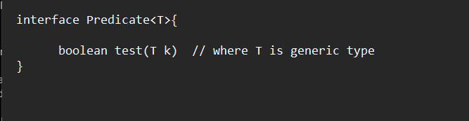

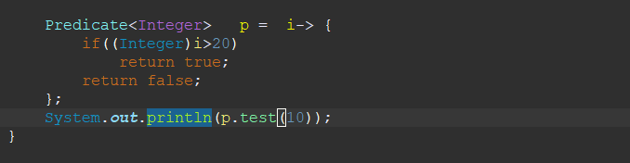

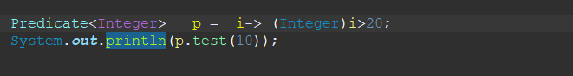

Predicates can be joined to form another predicate by using methods like negate(), and(), or().

P1.negate() to use condition opposite to p1

p1.and(p2), returns true when both p1 and p2 are true

p1.or(p2), returns true when any of p1 or p2 is true

we can also use a static method isEqual method to check equality in predicates

Predicate<String> p = Predicate.isEqual(“Paras”);

System.out.print(p.test(“Paras”)); // true will be printed in this case

We may also use if-else in place of predicate but if there are any big conditions , then we can create predicate and use it multiple times.

1. Function – It is similar to Predicate, but can return any type of value. Syntax of Function

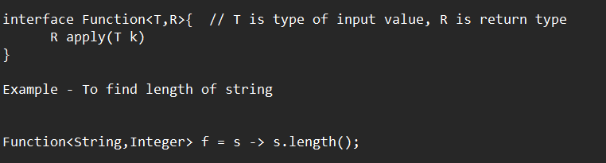

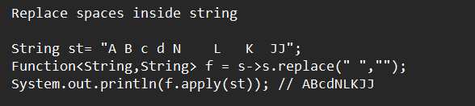

Function chaining(there are 2 methods inside function , inorder to execute two functions one after the other)

1. andThen() -> f1.andThen(f2) first f1 will be applied , then on the result f2 will be applied.
2. Compose() - > f1.compose(f2), first f2 will be applied , then on the result f1 will be applied.
3. Consumer

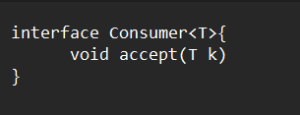

Example of consumer chaining

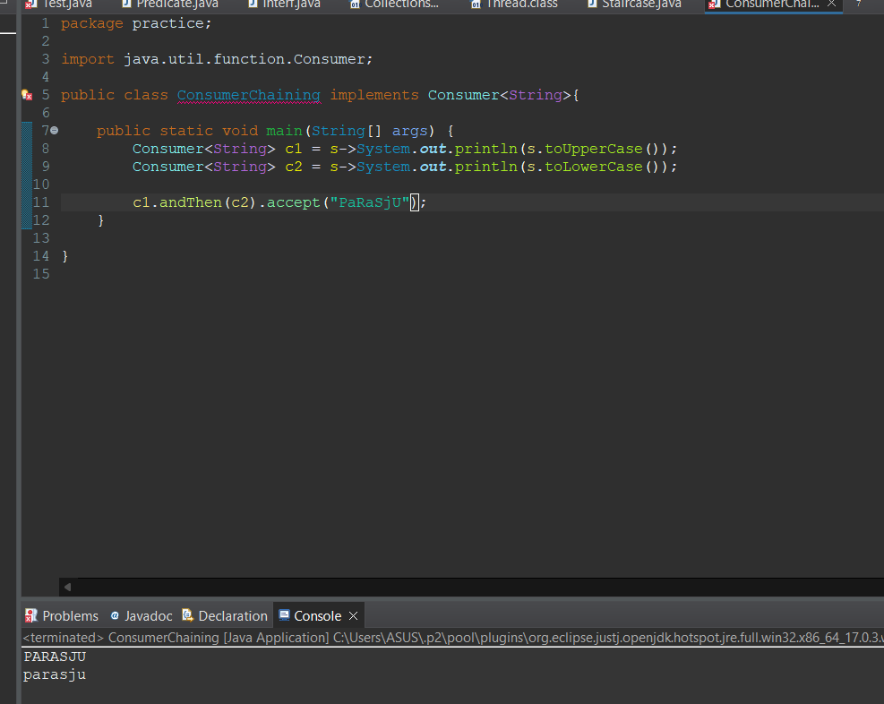

1. Supplier

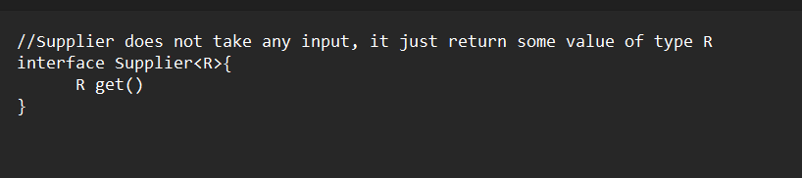

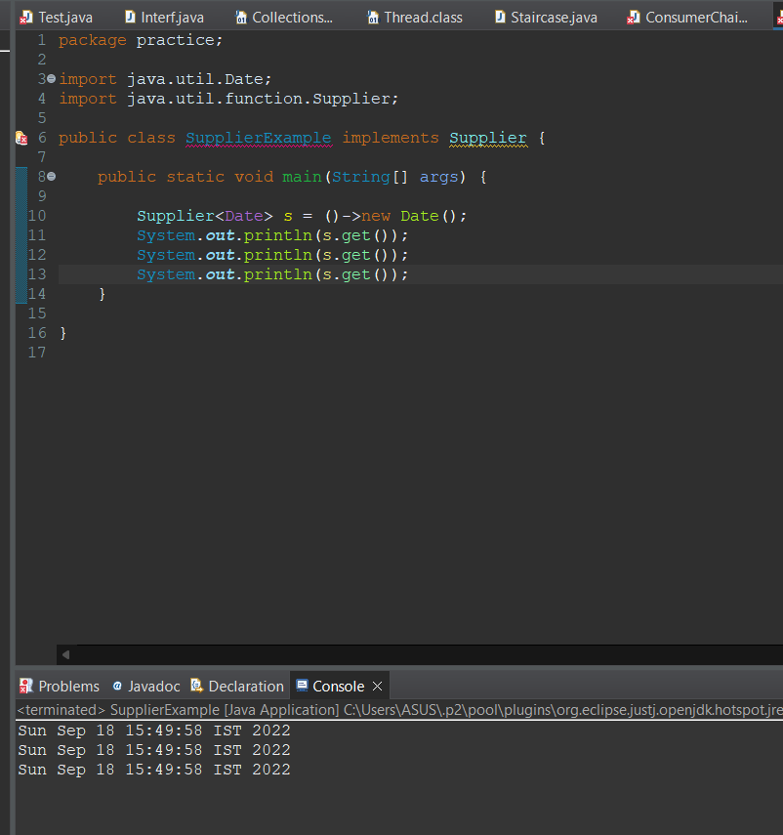

In the case of Predicate, Function, and Consumer, all of them take a single input value

If the number of input values is two then we can use BiPredicate, BiFunction and BiConsumer

**Autoboxing** – automatic conversion from primitive type to Wrapper Object.

Example

Integer I =10; (before 1.4 version this was not possible)

at runtime this code(Integer I = Integer.valueOf(10)) is executed.

**AutoUnboxing** – automatic conversion of Wrapper object to primitive type.

Example

int x = I;

at runtime this code(int x = I.intValue()) is executed

Due to autoboxing and unboxing, there are performance issues with the functional Interfaces, so there is a need for a functional interface with a primitive type. Consider the below code

Function<Integer,Integer> f = i-> i*i;

Sopln(f.apply(10));

In this case, Integer would be converted to int and int would be converted to Integer i.e there will be autoboxing and autounboxing many times.

**Primitive Type Predicate**

Some primitive type predicates include:

1. IntPredicate
2. LongPredicate
3. DoublePredicate

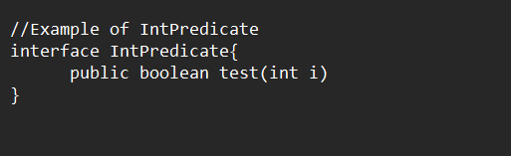

Similarly, there are primitive types of Function Interfaces as well

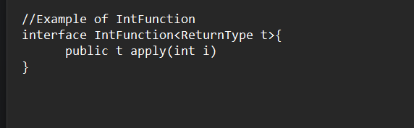

In this only return type will be converted into Integer.

These interfaces are present in java.util.function

**Method Reference by Double Colon (::)**

It is used to refer to a particular method, in such case we don’t have to write the whole implementation. It’s biggest advantage is code reusability. In order to use method reference , both methods should have the same argument type. It is an alternative syntax to lambda expression.

Example in code:

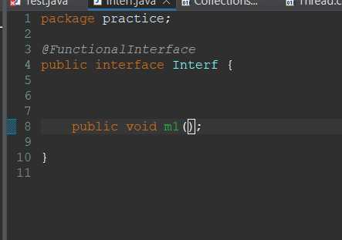

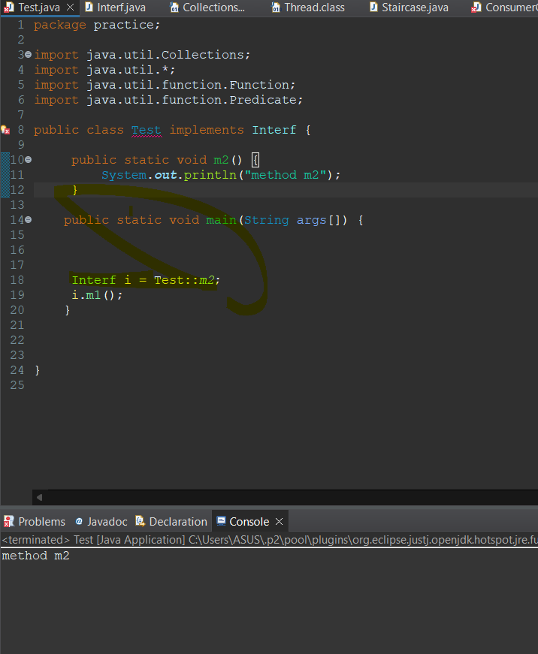

Syntax for method reference

1. Static methods

className::methodName

Test::m2;

1. Instance method

objectName::methodName

Test t = new Test();

t::m2;

Syntax for constructor reference

className::new

**Collection**

Collection is a group of objects represented as a single entity. Ex -List, Set, Map etc.

Comparator Interface contains only one abstract method i.e compare method so we can use lambda expression to define our own sorting (customized sorting).

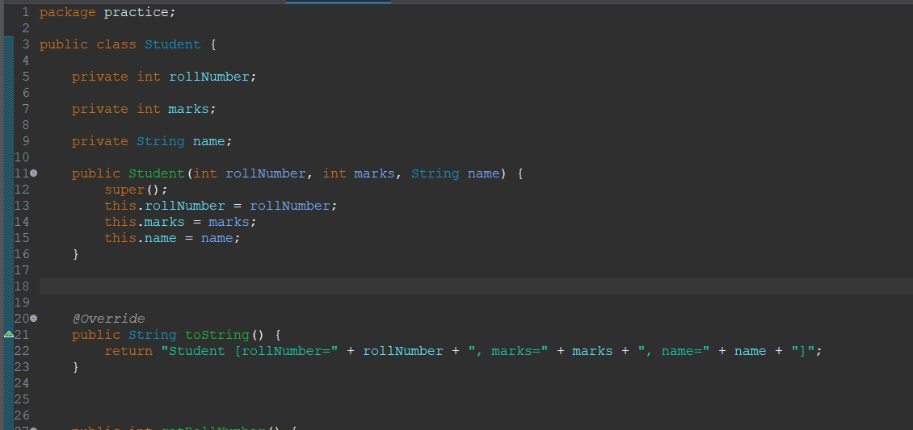

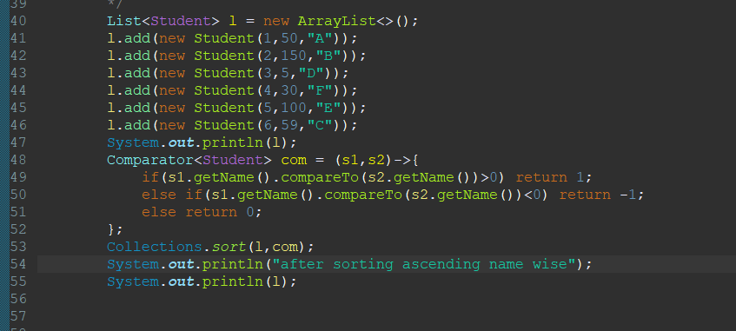

**Anonymous Inner Classes**

It is an inner class that does not have any name.

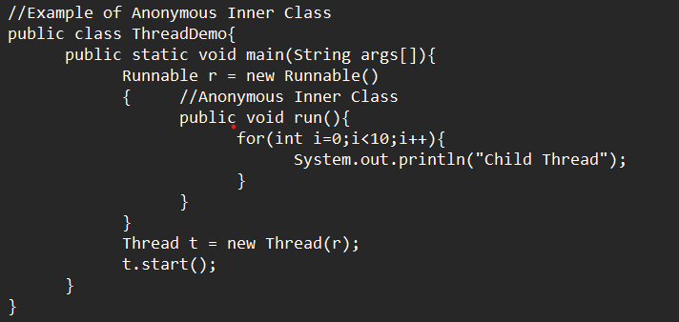

Same code can be re-written using lambda expression

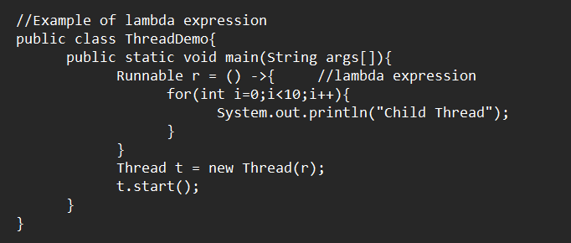

**All Anonymous inner classes cannot be replaced with a lambda function.**

Some scenarios are where anonymous inner classes can be implemented but lambda expression cannot be implemented.

1. AIC can extend a concrete class (A concrete class is a class that has an implementation for all of its methods. They cannot have any unimplemented methods)
2. AIC can extend abstract class
3. AIC can implement an interface that contains multiple methods

Inside AIC instance variables can be declared and can be accessed using this keyword, while in lambda expression local variables can be declared but not instance variables.

A local variable used inside the lambda function is implicitly final i.e they cannot be changed, although instance/class variables can be changed.

**Default methods inside Interfaces**

Until Java 1.7, the methods declared inside interfaces were by default public and abstract.

Variables are public static final.

From Java 1.8, we can declare methods inside the interface with default keyword i.e methods have their implementation inside interfaces. A class implementing this interface may use the existing function or override it.

**Special Case: when a class implements two interfaces that contain same method with different implementation**

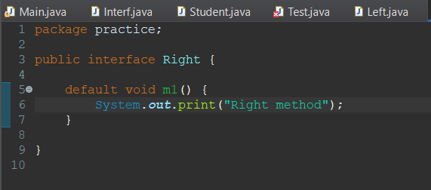

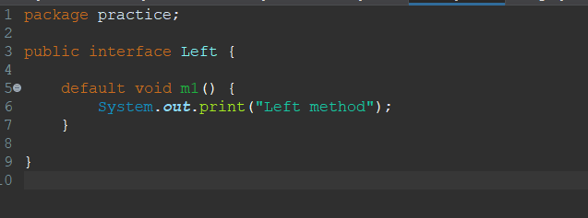

**It will give compilation error :** Duplicate default methods named m1 with the parameters () and () are inherited from the types Right and Left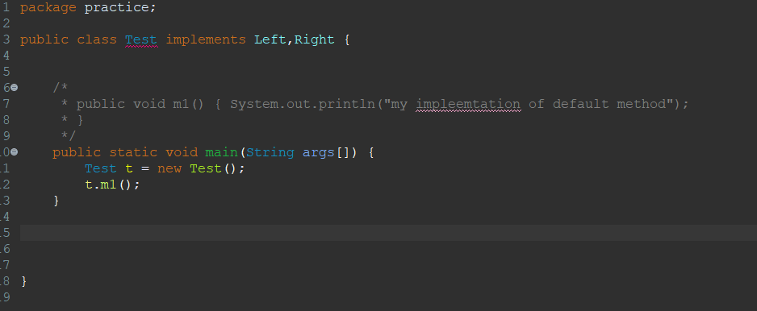

There could be two solution in such cases:

1. Create your own implementation of m1 method in Test class.
2. Create new method of m1 in Test class and use implementation of Left or Right as displayed below**.**

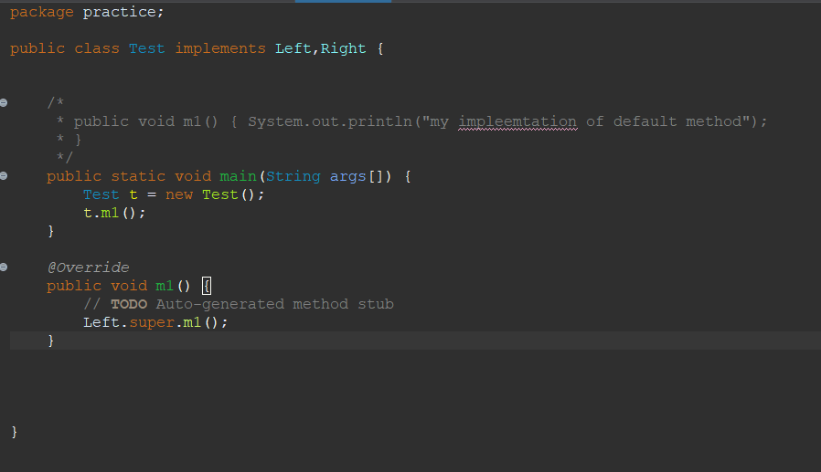

**Differences between an interface with default methods and abstract classes**

1. **In IDM, variables are public, static, and final and we can’t declare instance variables whereas in abstract classes we can declare instance variables.**
2. **In IDM we can’t declare constructors whereas inside the abstract class we can declare constructors.**
3. **In IDM functional interface with default methods can refer to lambda expression which is not possible in the case of abstract classes.**
4. **In IDM we can’t declare instance and static block which is possible in the case of abstract classes.**
5. **In IDM ,we can’t override object class methods but in abstract, we can override them (object class methods like – equals, hashcode)**

**Static methods inside Interfaces**

We can declare static methods inside Interfaces, which can be accessed inside implementation classes only by using the Interface name i.e INTERFACE_NAME.METHOD_NAME.

The overriding concept is not applicable to static methods. We can declare the same methods inside the implementation classes but cannot override them.

Example –

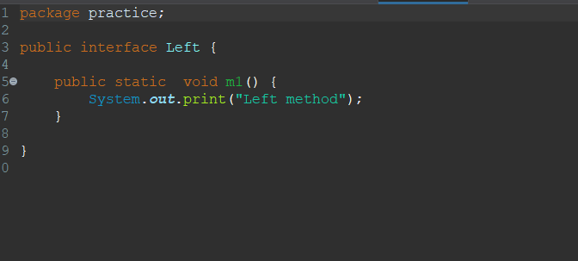

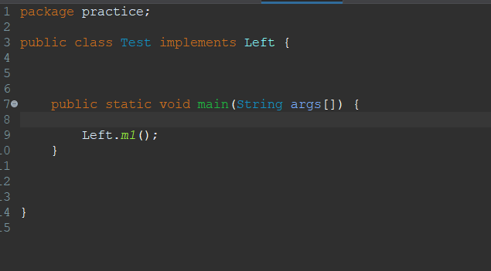

We can also write the main method inside the interface and execute the interface from the command prompt.

**Stream**

It is used to process objects from the collection. Example

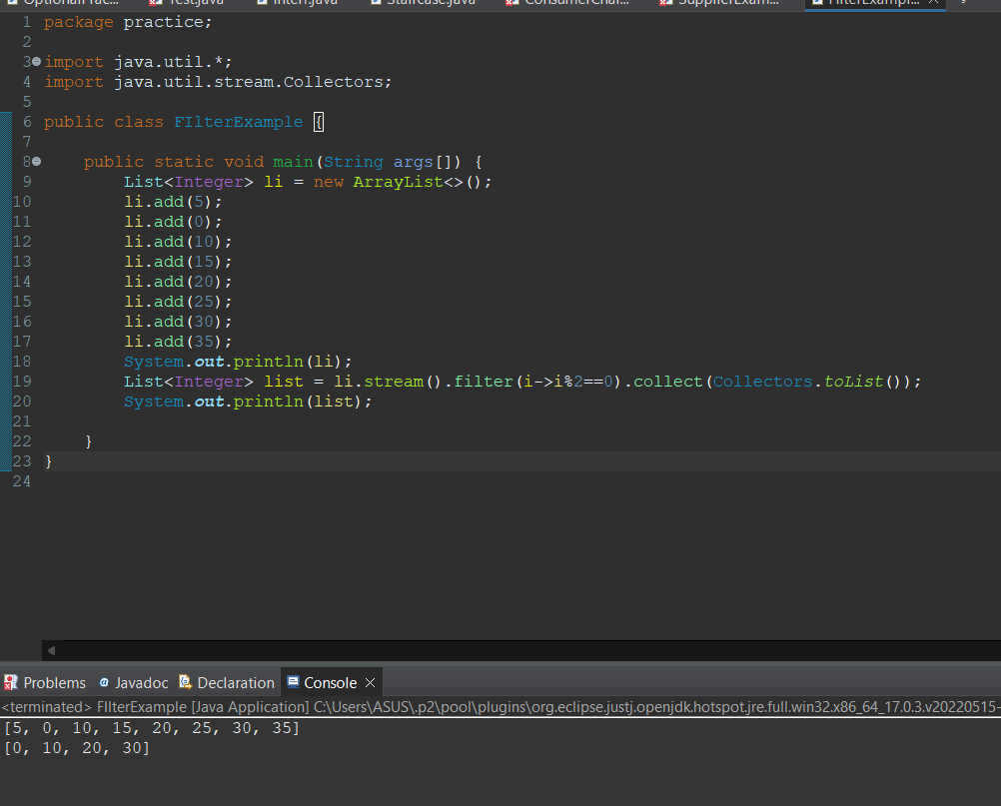

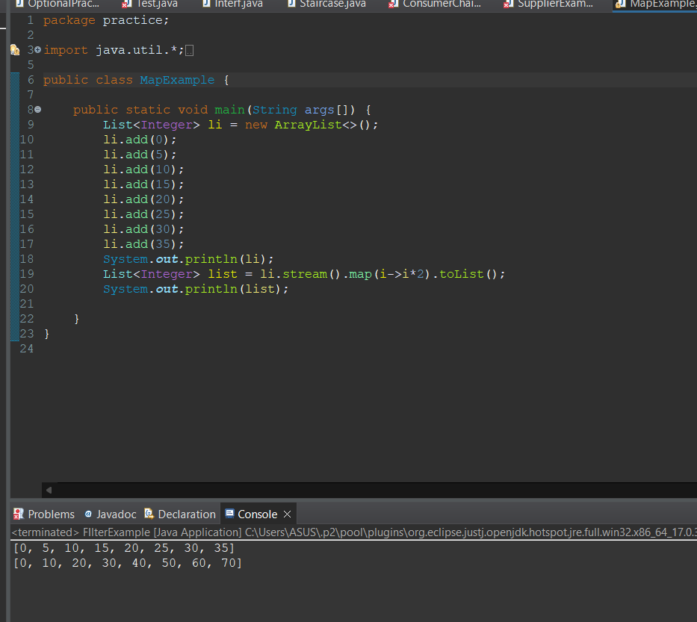

Stream objects can be created by using any collection object by calling stream method on that object.

Stream st = col.stream()

Where col is any collection object. stream() method is present inside Collection interface as default method.

Stream is an interface present in java.util.stream package.

There are 2 configurations for stream()

1. Filter – It checks some conditions as it takes a predicate as an argument.
2. Map – It performs some operation and returns some value as it takes Function as an argument.

Example of this are present in the above screenshot.

Processing of stream by different methods:

1. collect() method – This method collects elements from the stream and adds them to the specified collection.



1. count() method – It returns number of elements present in stream.

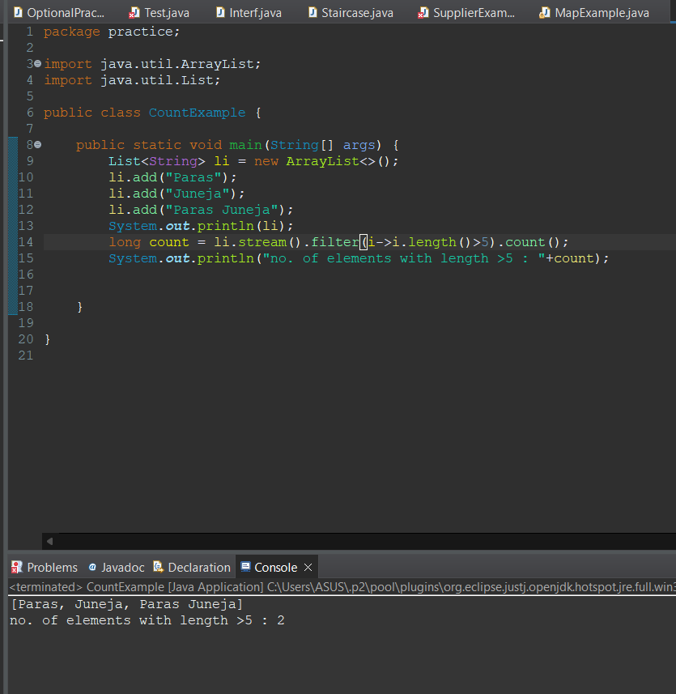

1. sorted() method – It is used to sort elements inside stream. It can sort based on default sorting order or customized sorting order. There are two implementations for that
2. sorted() – for default sorting order

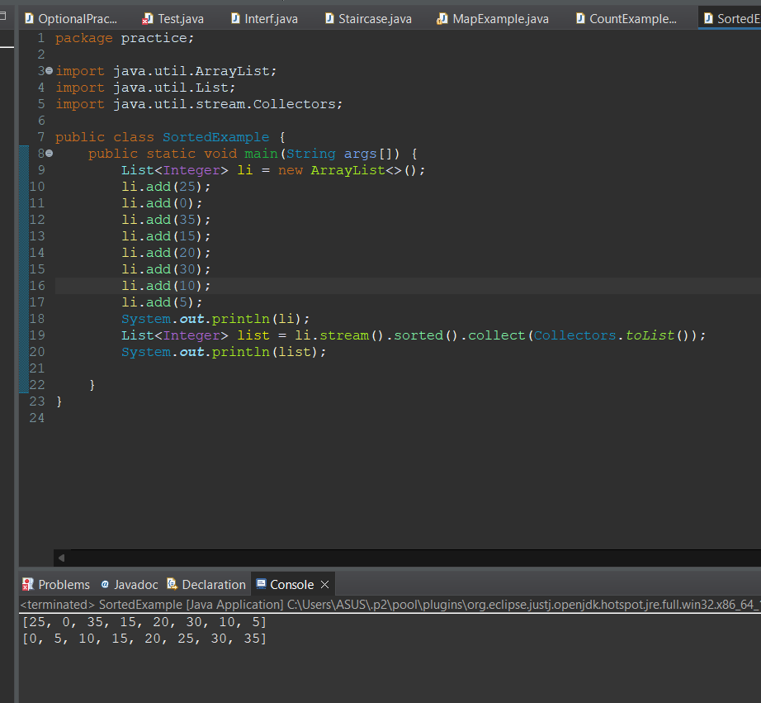

1. sorted(Comparator com) – for customized sorting order.

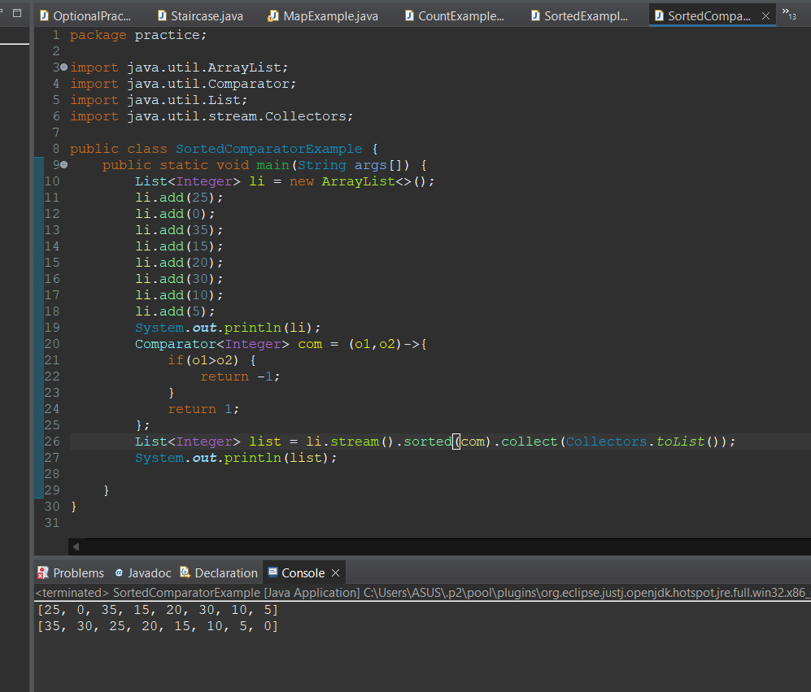

1. min() and max() methods – These are used to return minimum and maximum values present inside stream. It can only return this value when elements are present in sorted order that is why it takes Comparator object as an argument. It actually returns element at first index in case of min() and last index in case of max().
2. forEach() method- It does not return any value , it just takes lambda expression as an argument and apply that on each element present in stream.

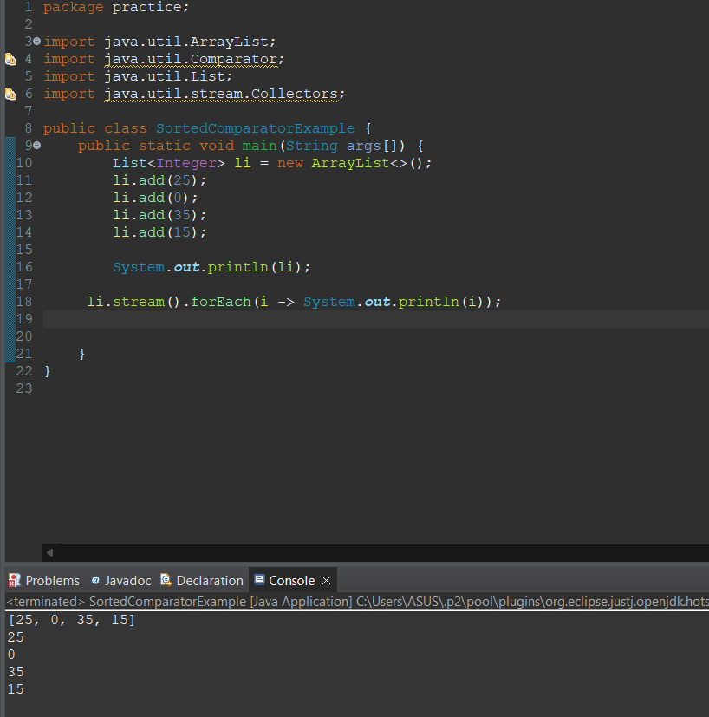

1. toArray() method – It is used to copy elements present in streams into specified array.
2. Stream.of() – stream is not restricted to Collection, it can be used with any group of values or Arrays.

**Date and Time API**

Joda time api was introduced in java 8. It is part of java.time package. There are major classes inside it LocalDate, LocalTime, LocalDateTime.

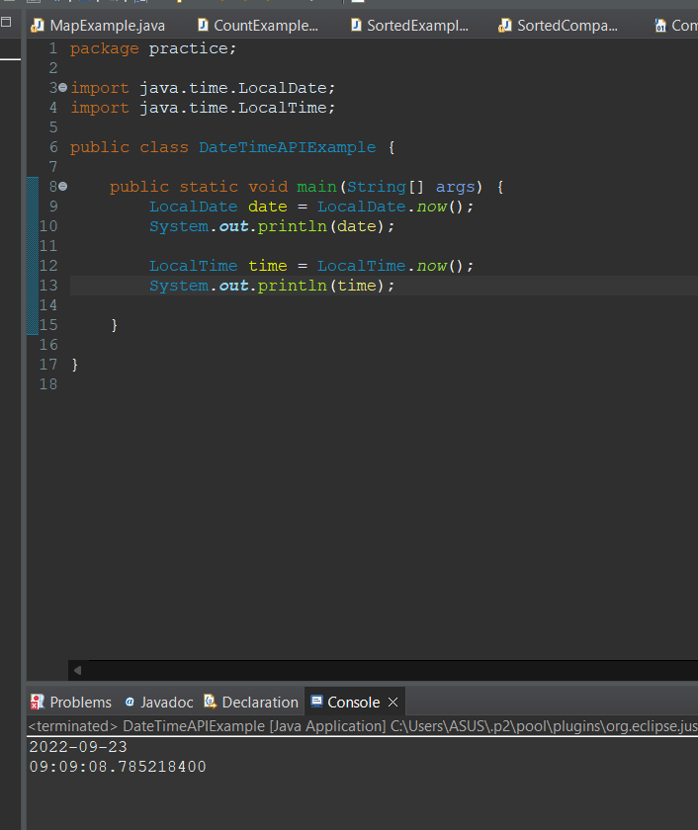

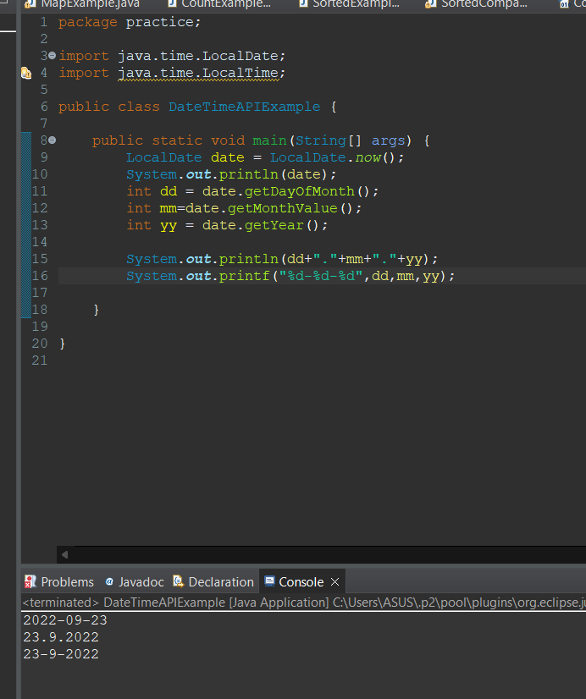

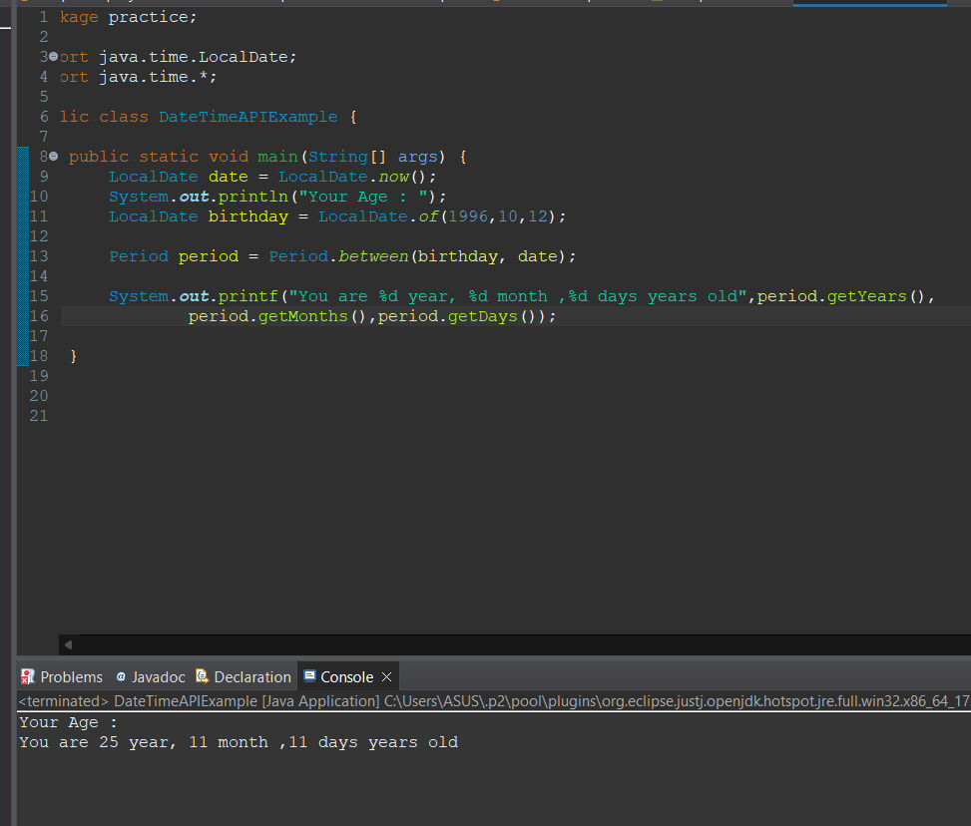

**Java Interview Question**

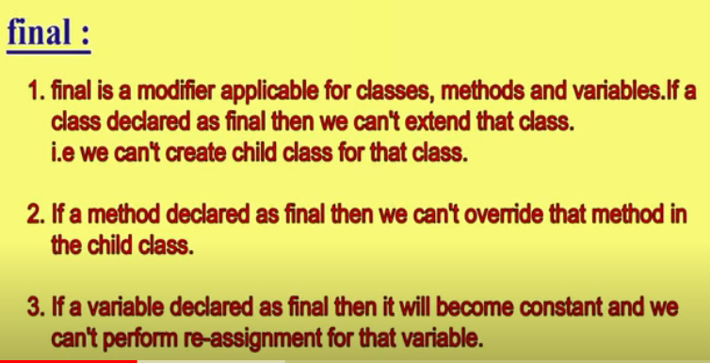

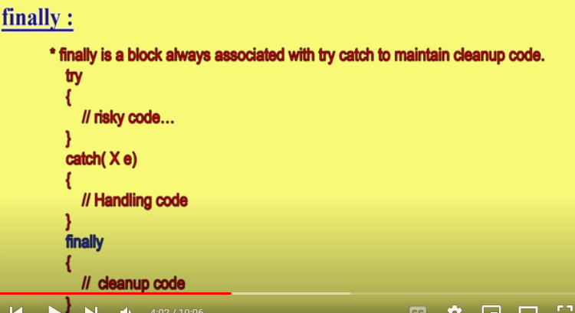

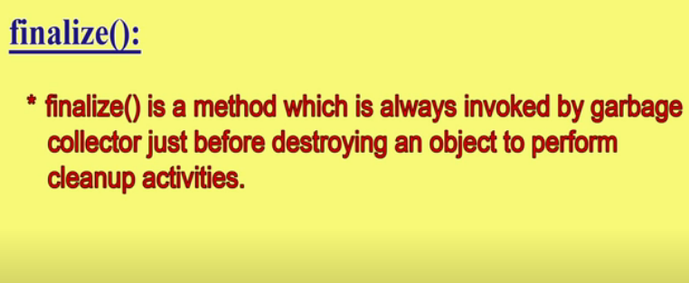

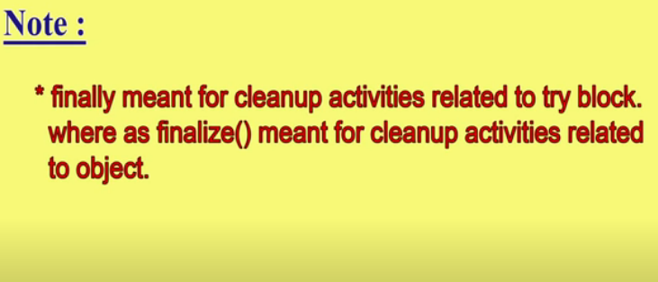

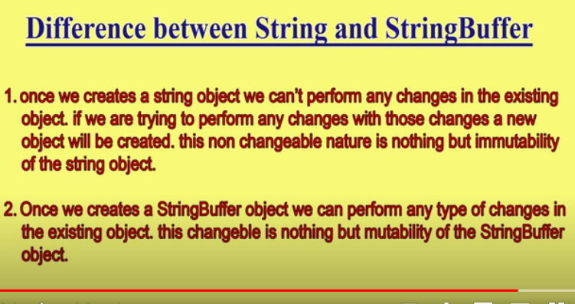

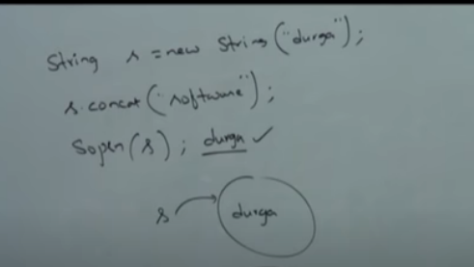

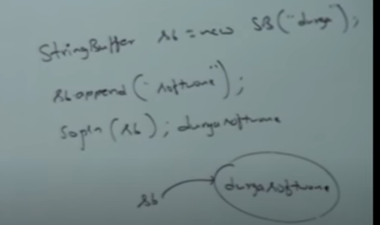

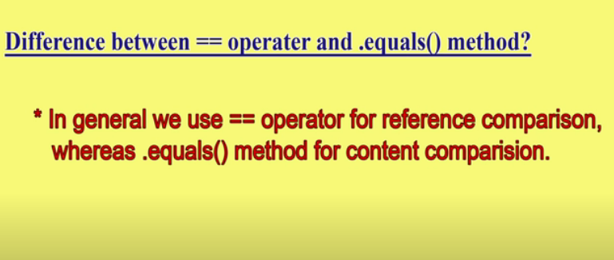

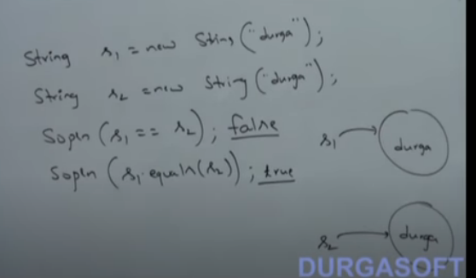

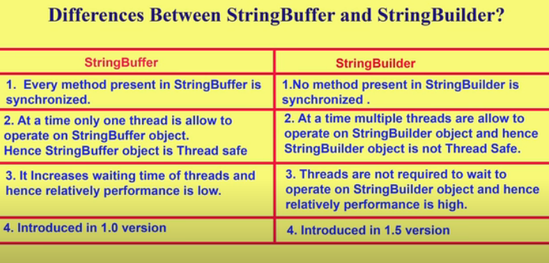

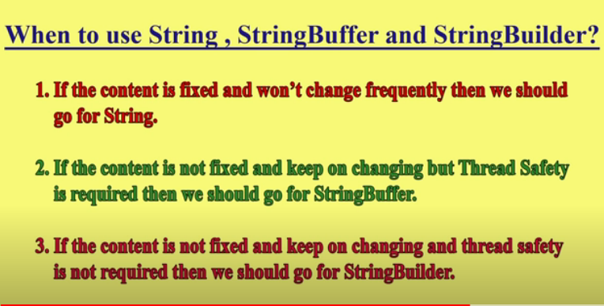

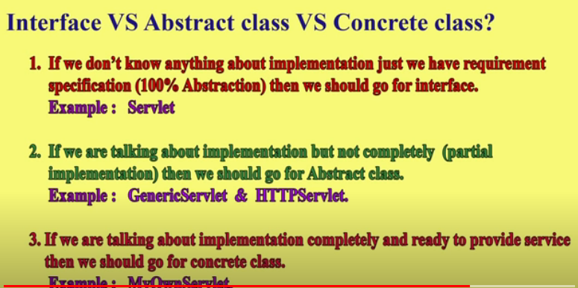

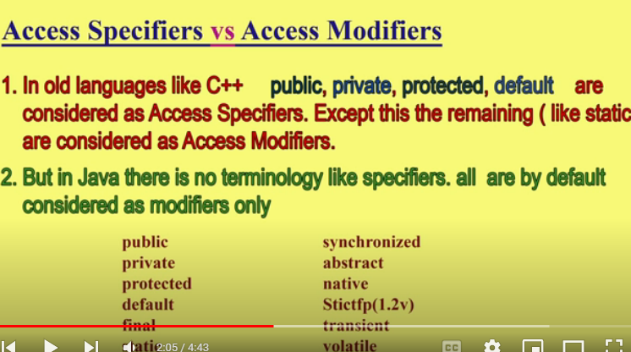

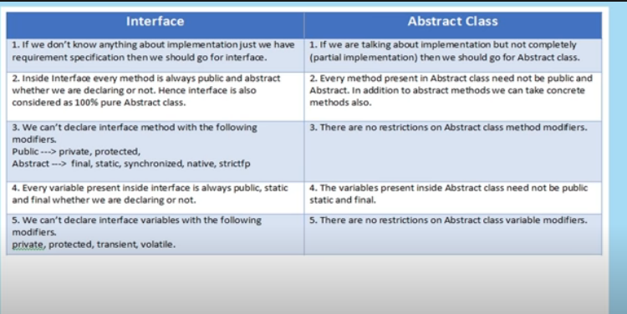

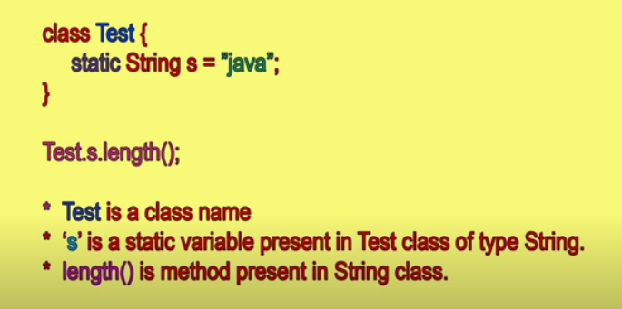

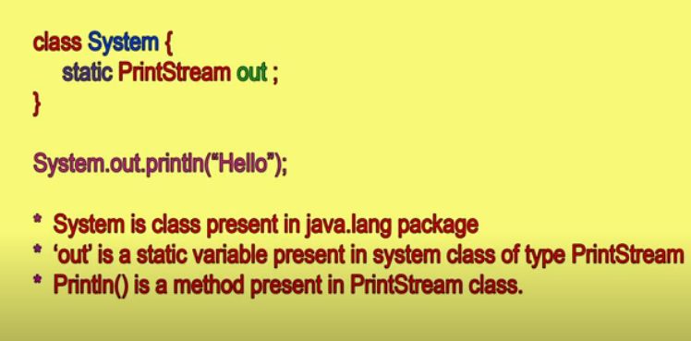

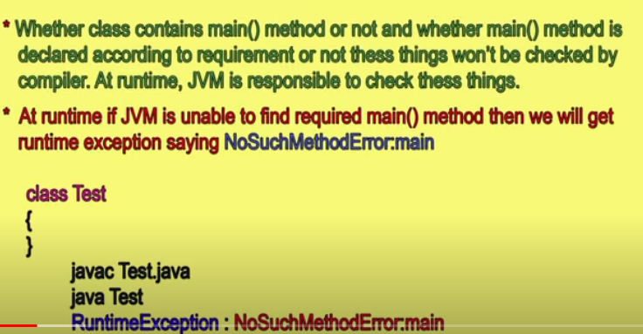

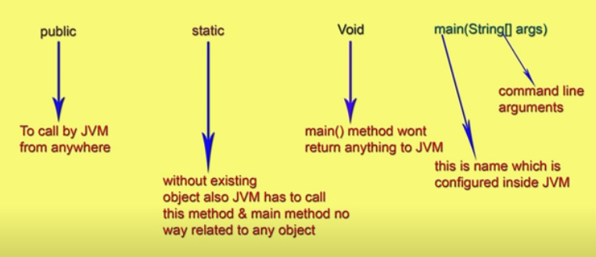

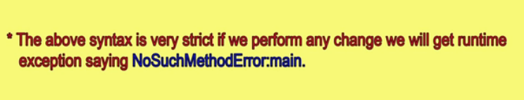

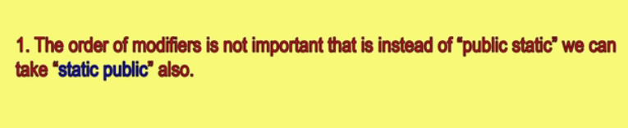

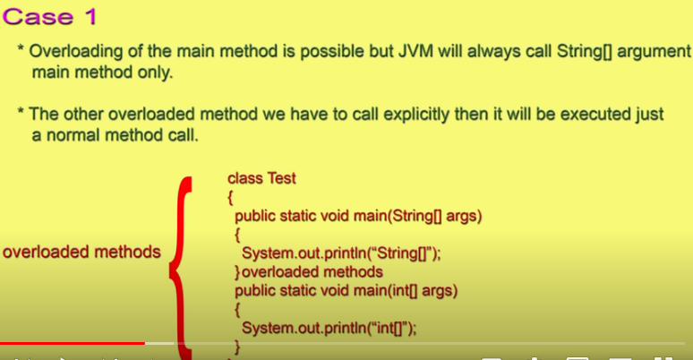

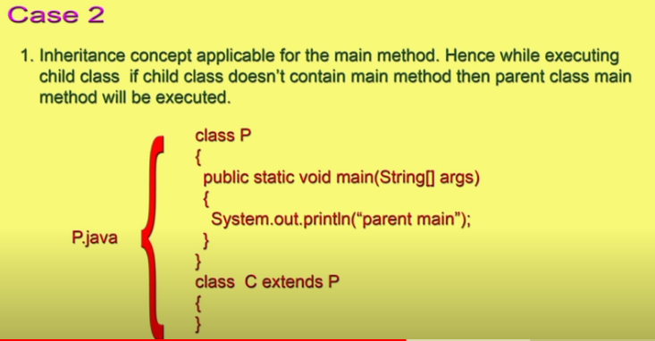

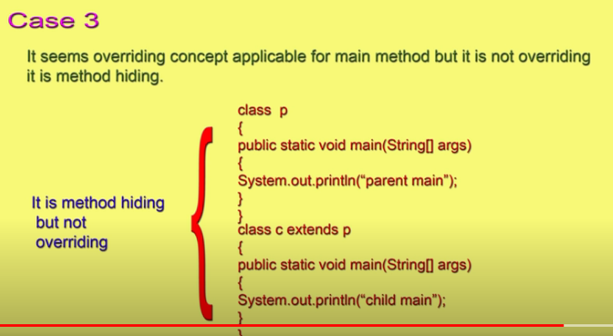

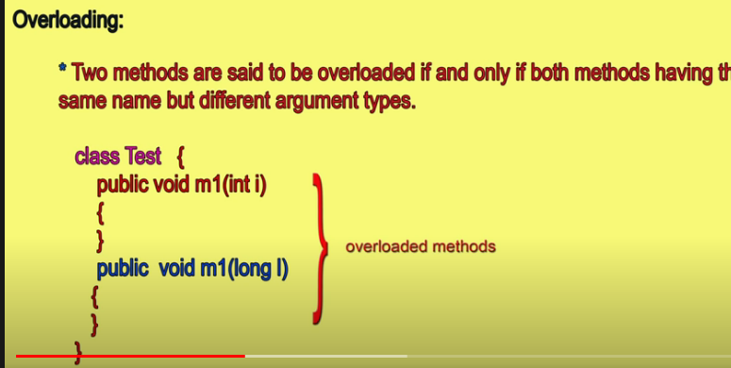

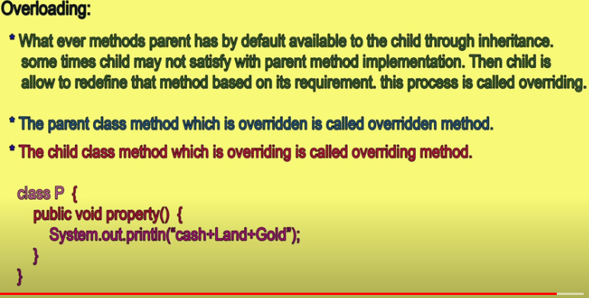

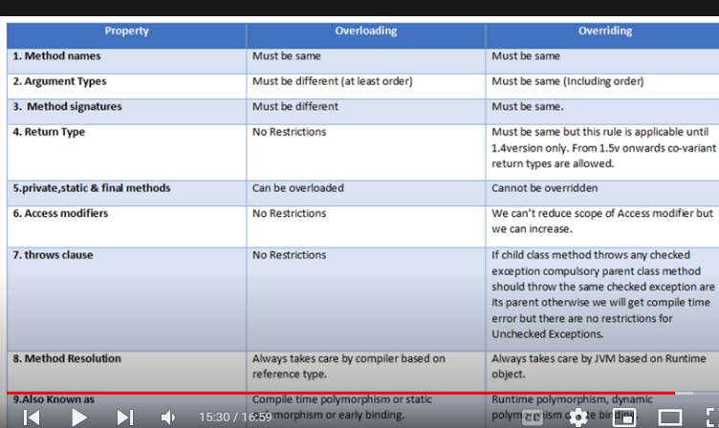

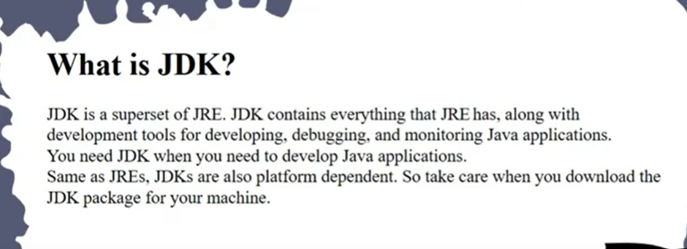

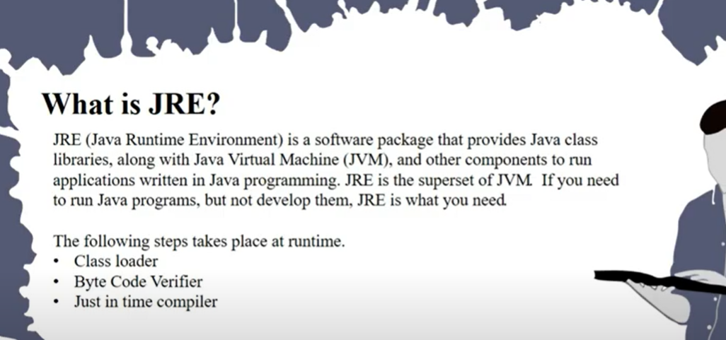

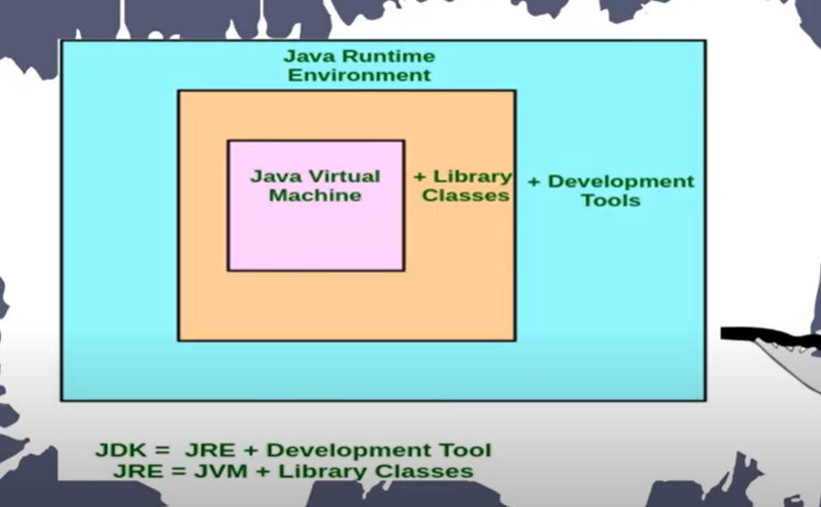

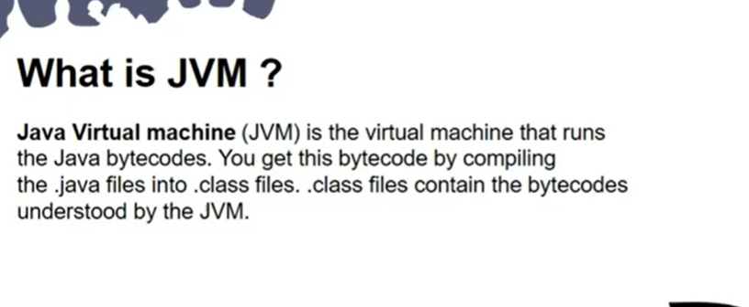

 Java Virtual Machine (JVM) is a engine that provides runtime environment to drive the Java Code or applications. It converts Java bytecode into **machines language**. JVM is a part of Java Run Environment (JRE).

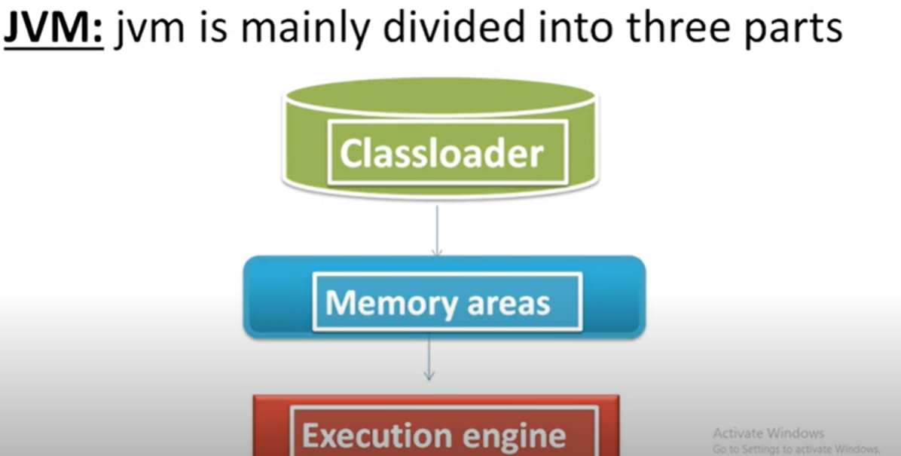

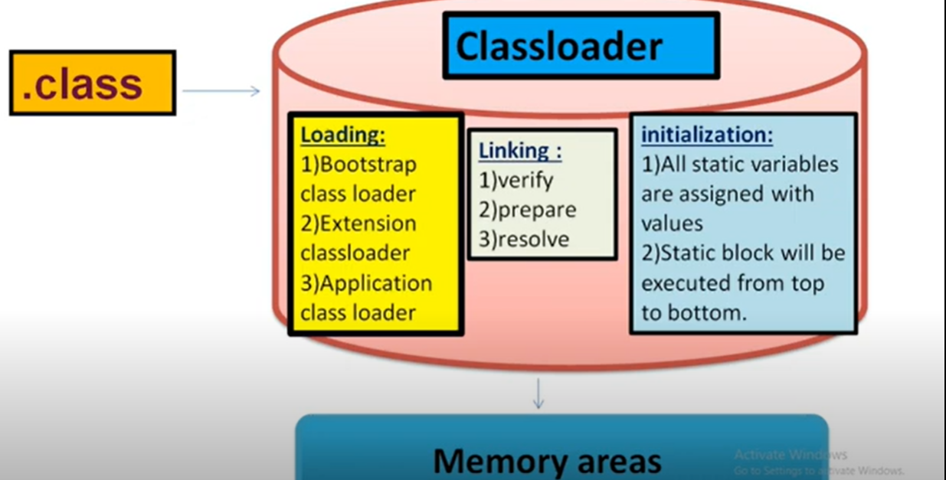

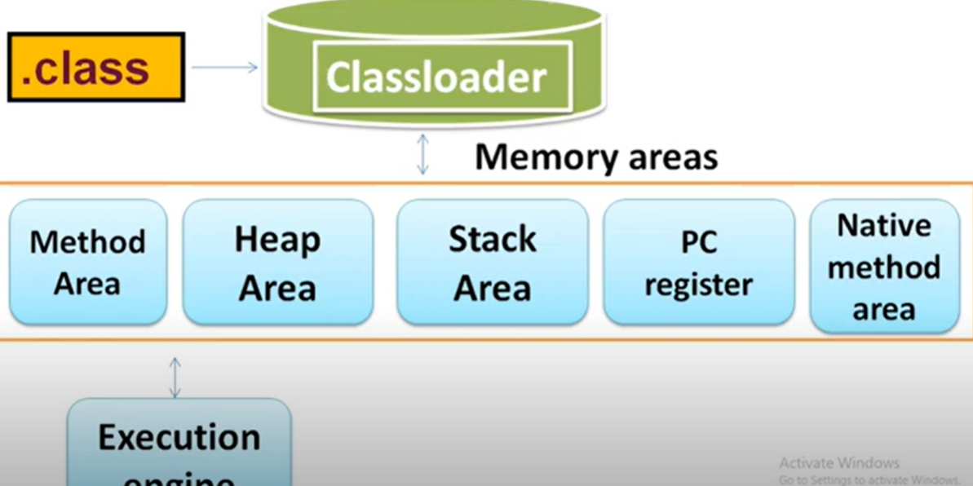



**String constant pool is present in heap area of jvm.**

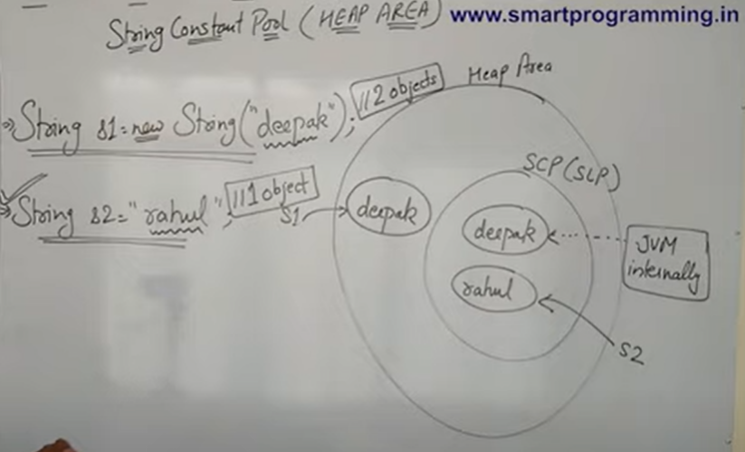



String s = new String(“Paras”)

This will create two objects i.e one in the heap area and another in the string constant pool.

String s1 = “Juneja”

This will create only 1 object in string constant pool.

String s2 = new String(“Paras”)

This will create a single object in heap area, it will not create it in string constant pool because there is already “Paras” in it.

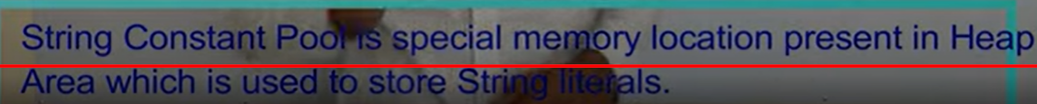



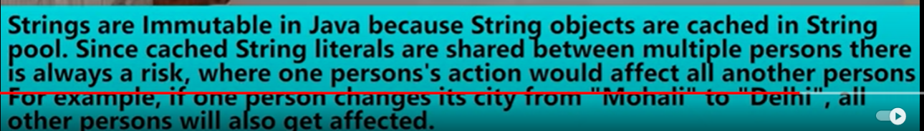

Stack and Heap memory

<https://www.baeldung.com/java-stack-heap>

## The Heap and the Nursery

Java objects reside in an area called *the heap*. The heap is created when the JVM starts up and may increase or decrease in size while the application runs. When the heap becomes full, *garbage* is *collected.*During the garbage collection objects that are no longer used are cleared, thus making space for new objects.

Note that the JVM uses more memory than just the heap. For example Java methods, thread stacks and native handles are allocated in memory separate from the heap, as well as JVM internal data structures.

The heap is sometimes divided into two areas (or *generations*) called the *nursery* (or *young space*) and the *old space*. The nursery is a part of the heap reserved for allocation of new objects. When the nursery becomes full, garbage is collected by running a special *young collection*, where all objects that have lived long enough in the nursery are *promoted* (moved) to the old space, thus freeing up the nursery for more object allocation. When the old space becomes full garbage is collected there, a process called an *old collection*.

The reasoning behind a nursery is that most objects are temporary and short lived. A young collection is designed to be swift at finding newly allocated objects that are still alive and moving them away from the nursery. Typically, a young collection frees a given amount of memory much faster than an old collection or a garbage collection of a single-generational heap (a heap without a nursery).

In R27.2.0 and later releases, a part of the nursery is reserved as a keep area. The keep area contains the most recently allocated objects in the nursery and is not garbage collected until the next young collection. This prevents objects from being promoted just because they were allocated right before a young collection started.

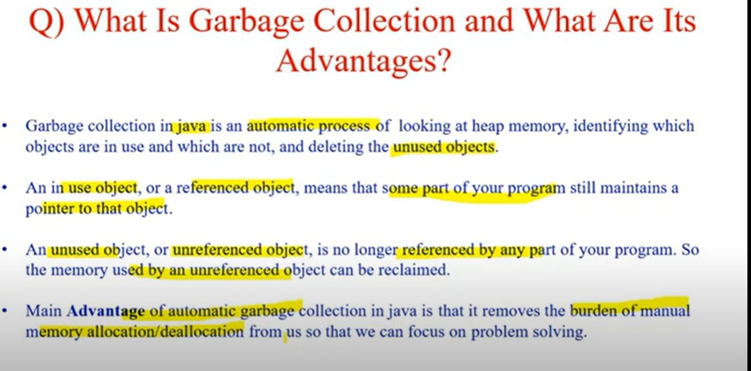

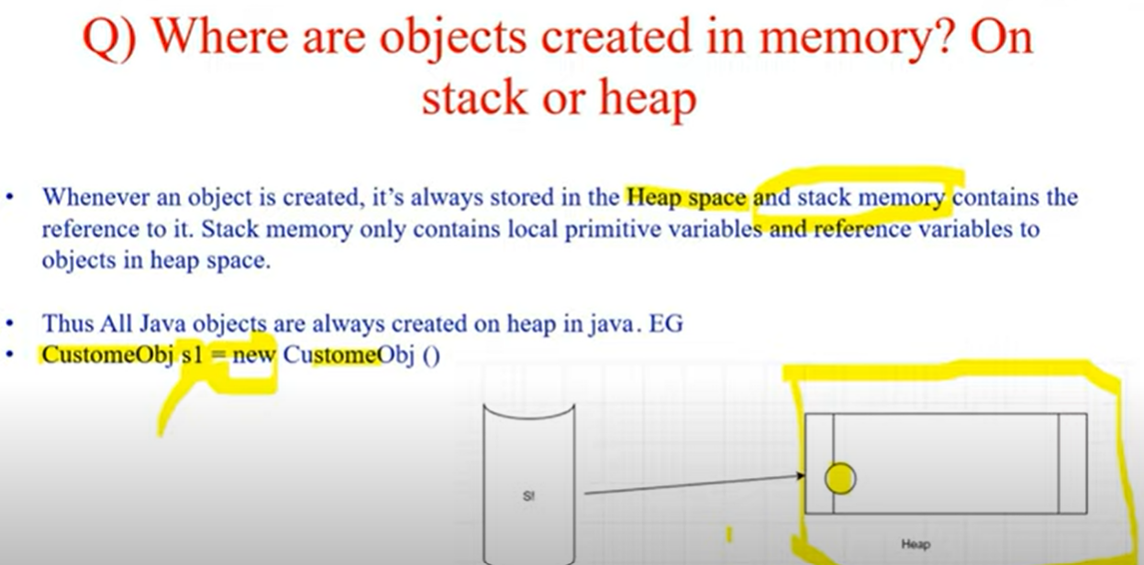

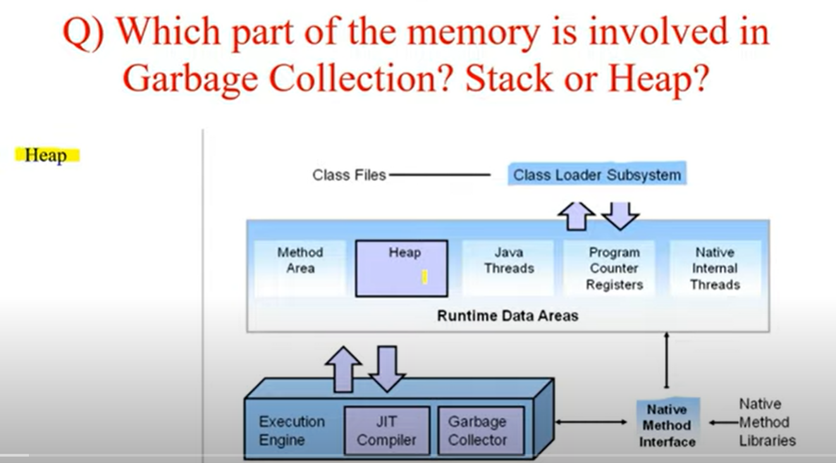

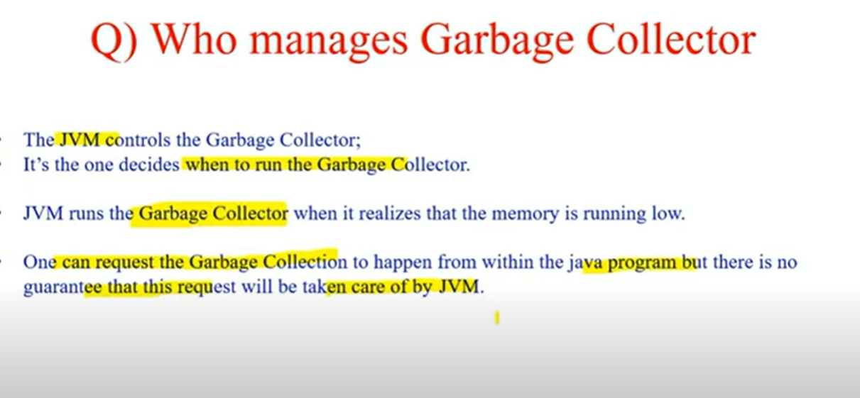

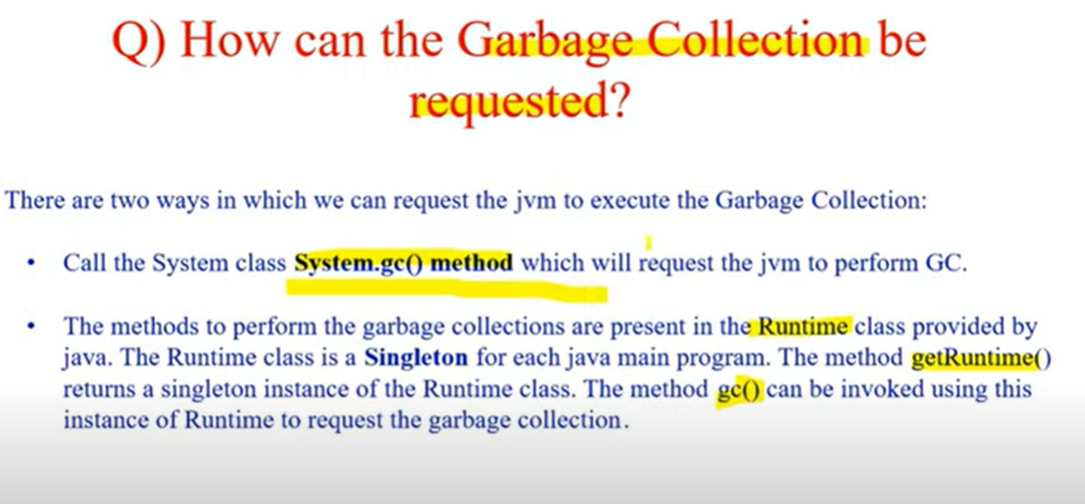

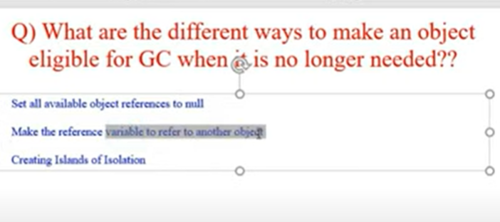

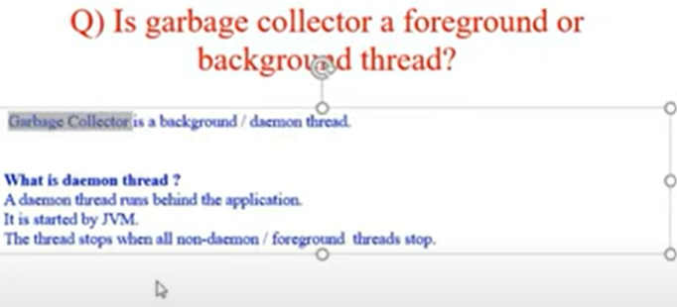

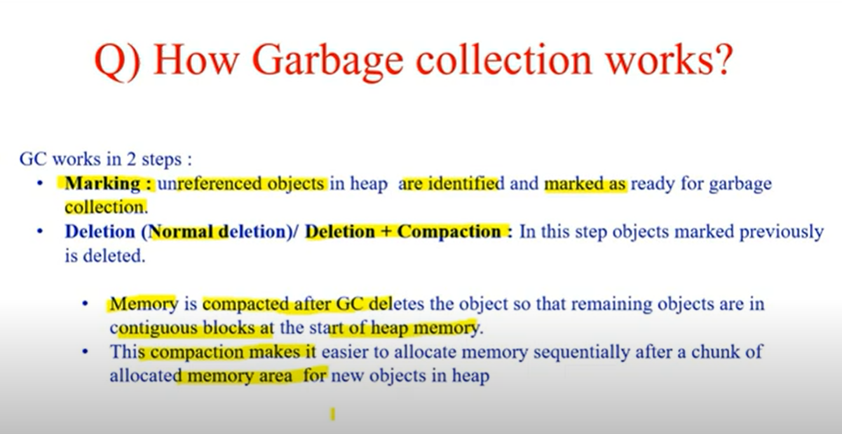

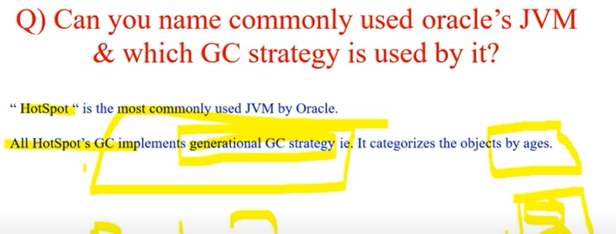

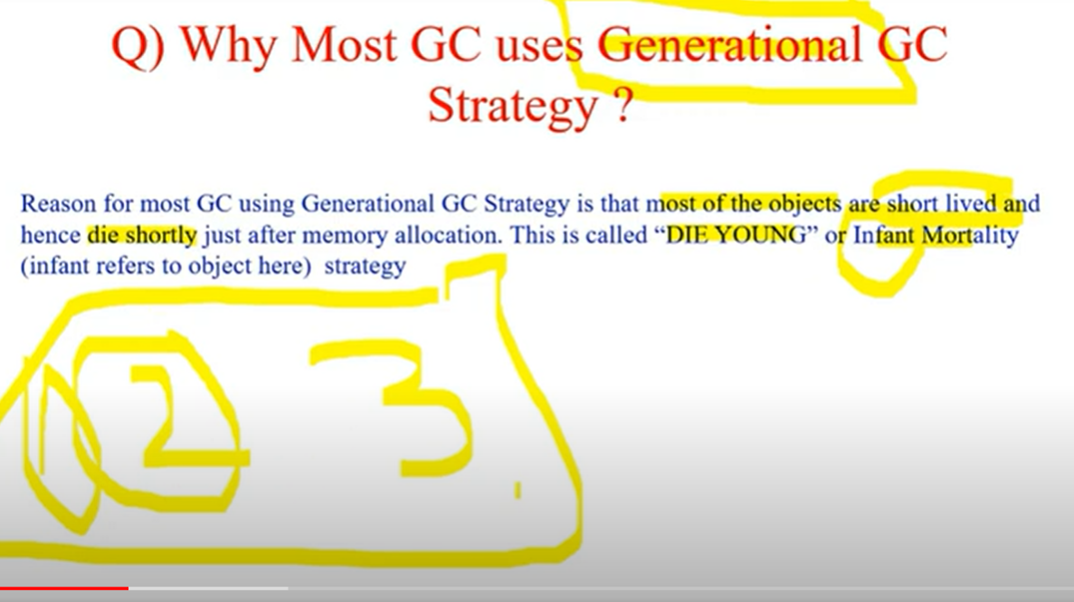

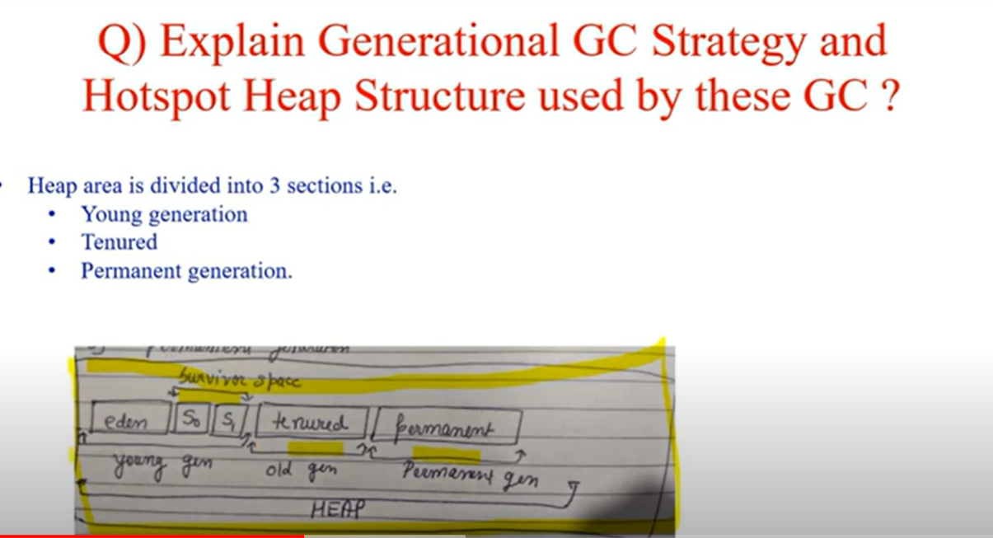

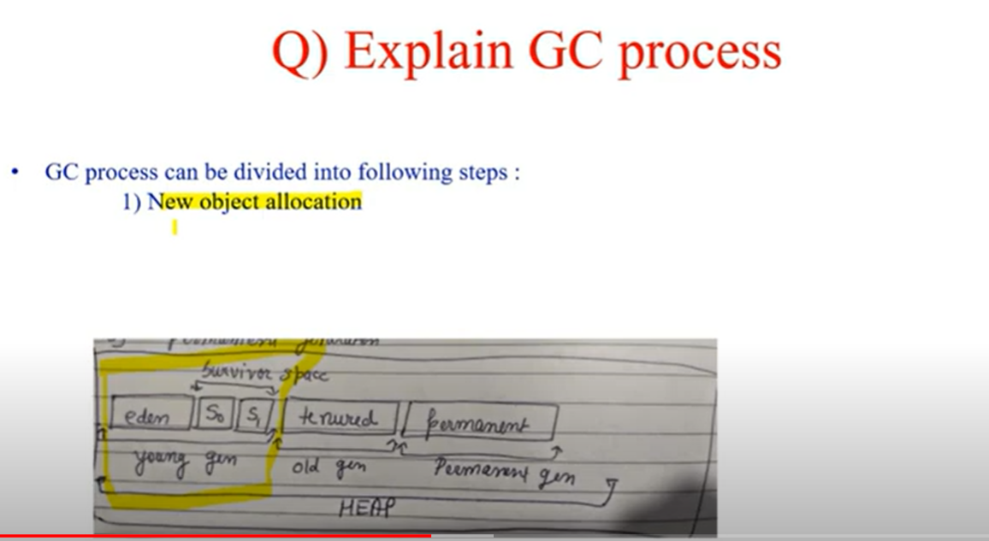

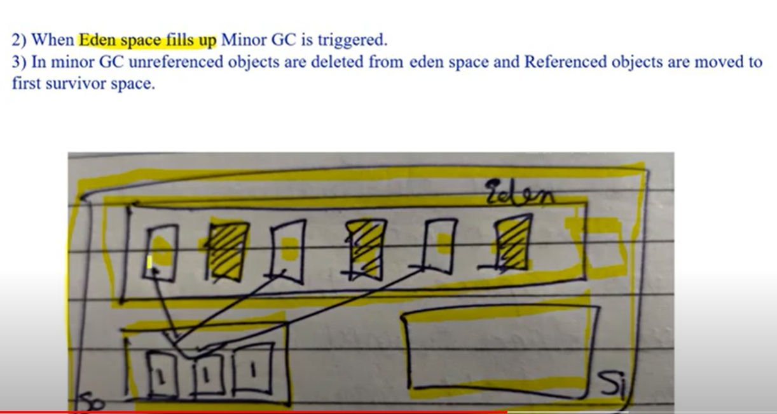

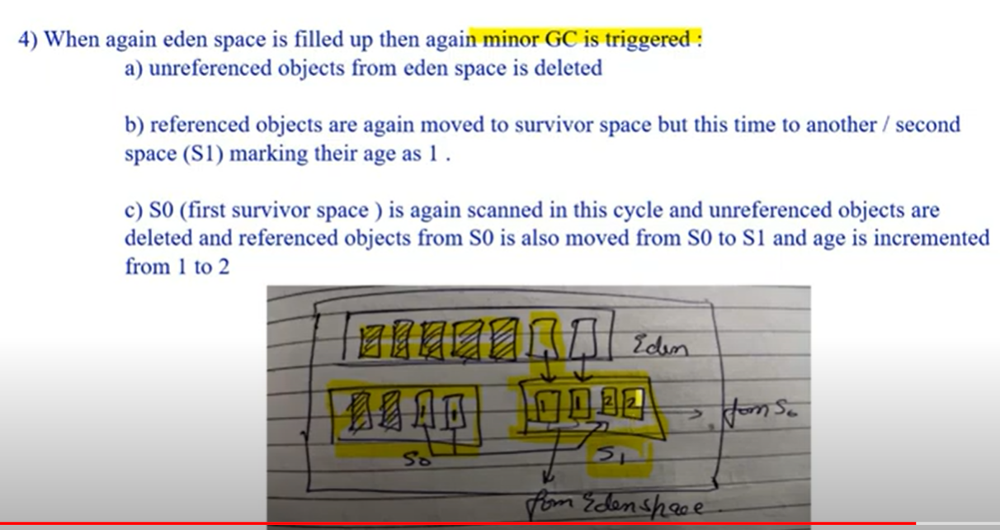

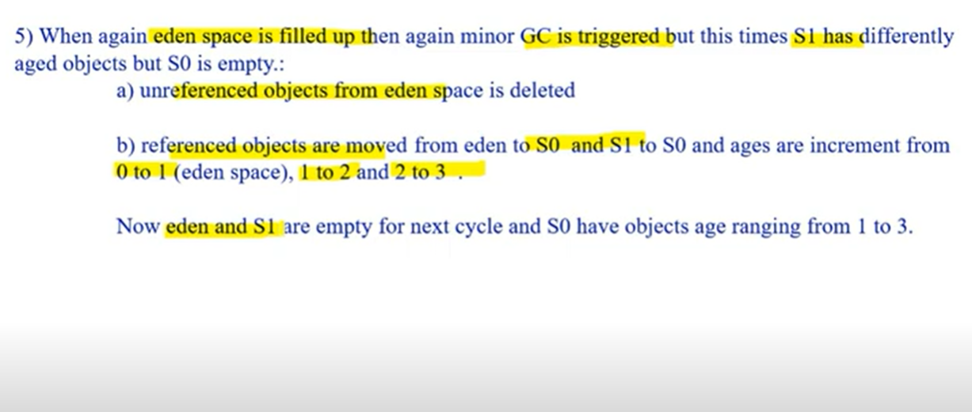

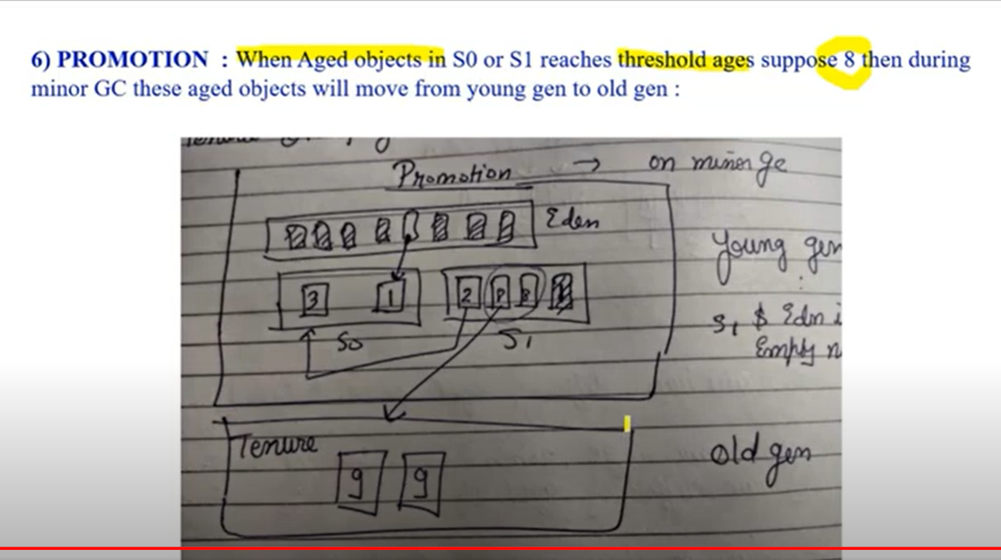

HashMap

It stores data in the form of key-value pairs. Its search insertion and deletion operation are of time complexity O(1).

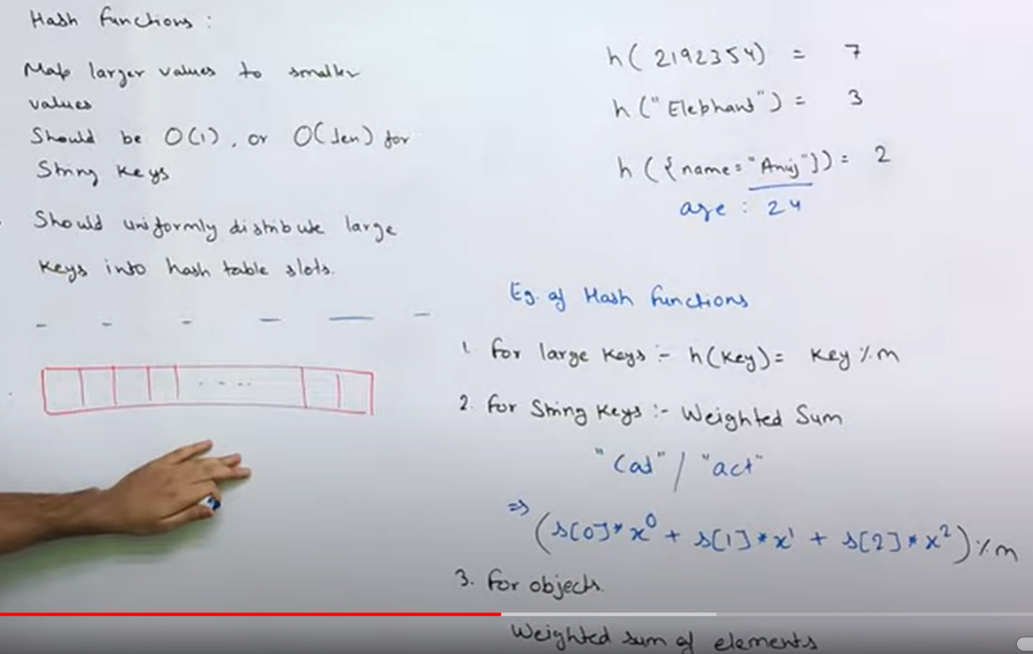

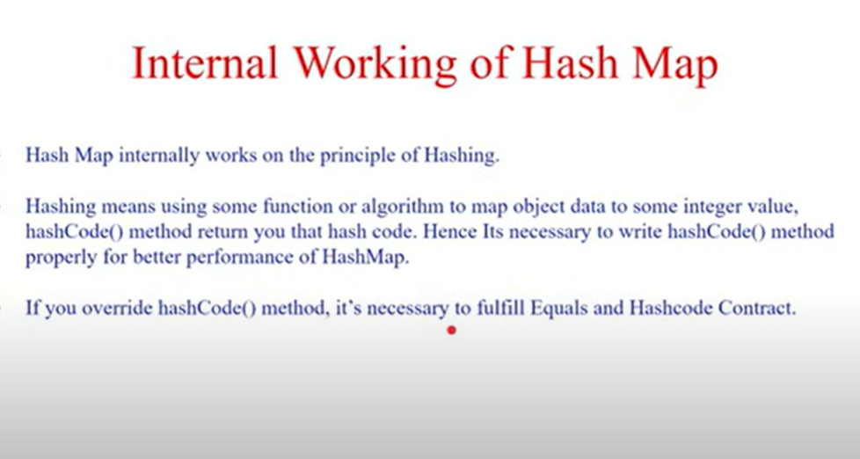

Hashing is performed in a Hashtable(it is an array of buckets). Hashing is performed on the key in the hashmap and based upon those key entry object(combination of key-value pairs) is stored. Hashed key is the bucket location.

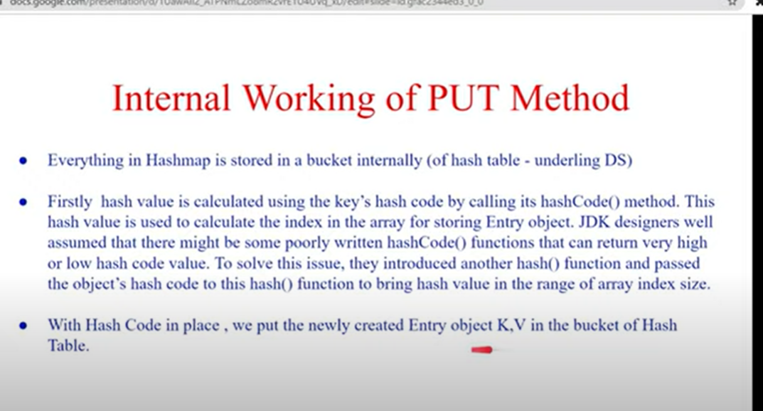

If the hashed value of 2 objects is same, then it would internally create a linked list of entry objects(Map.Entry<K,V>) and store it in the same bucket of the hash table.

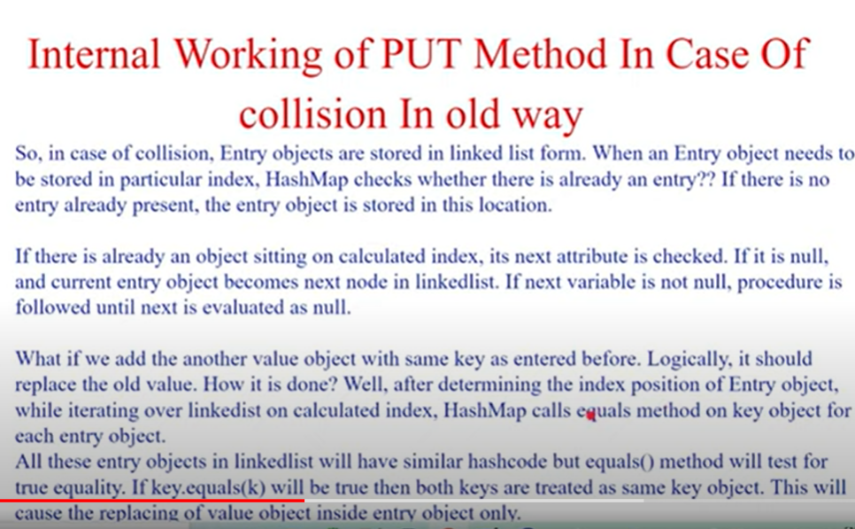

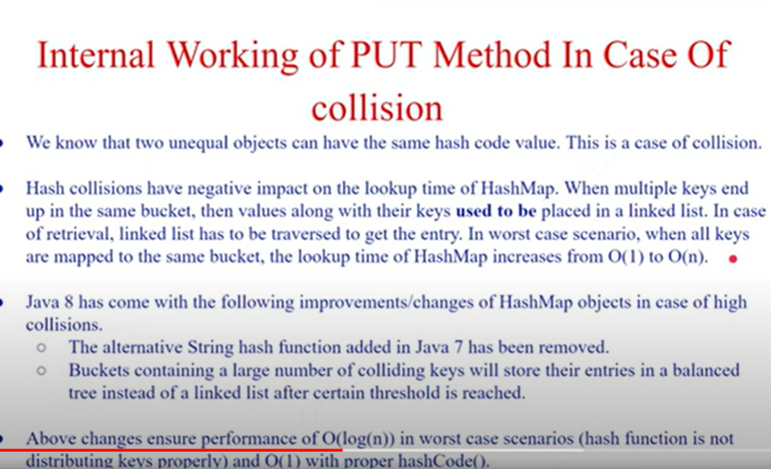

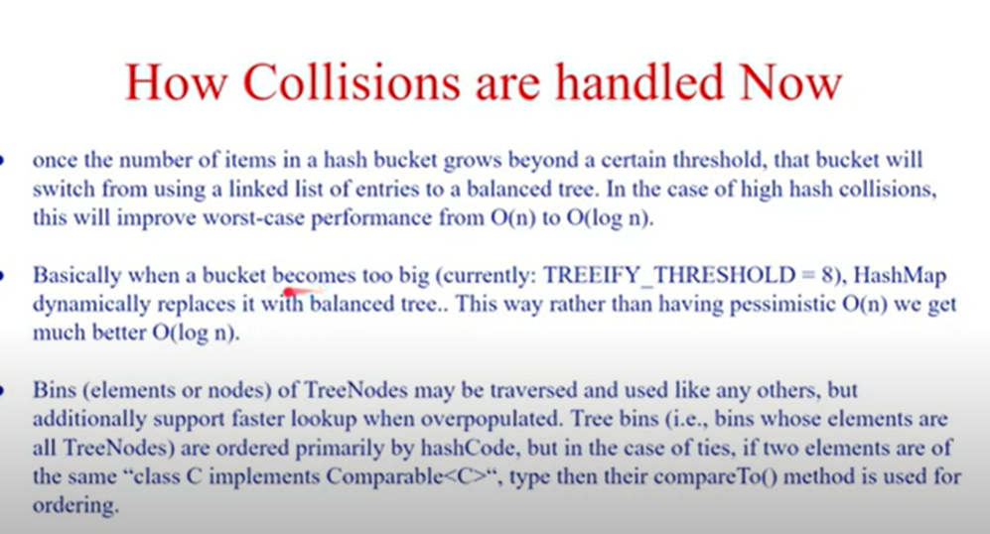

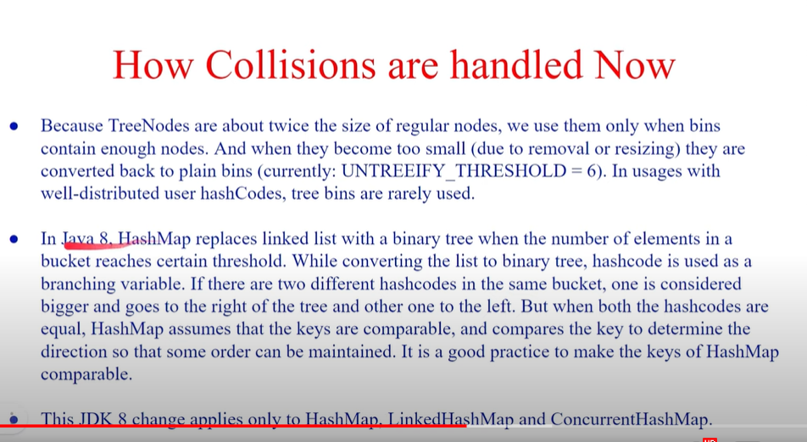

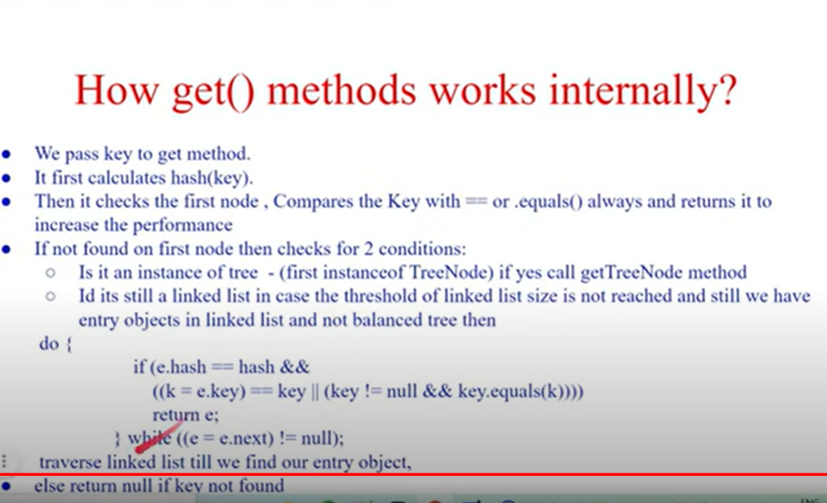

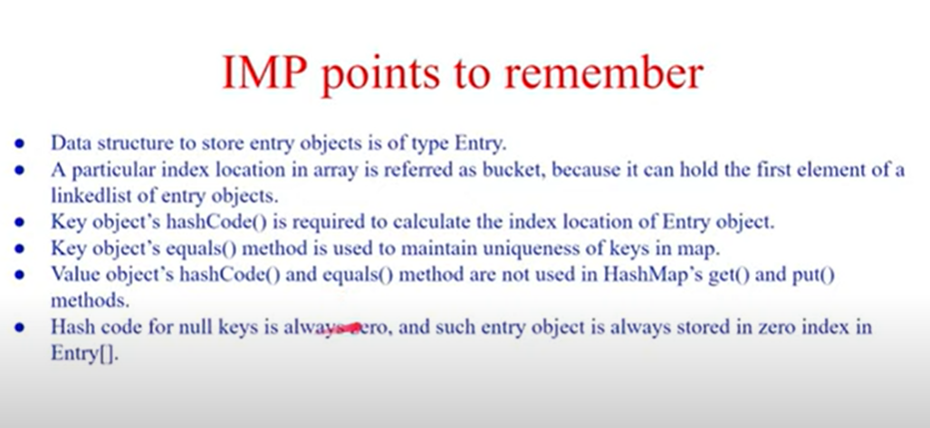

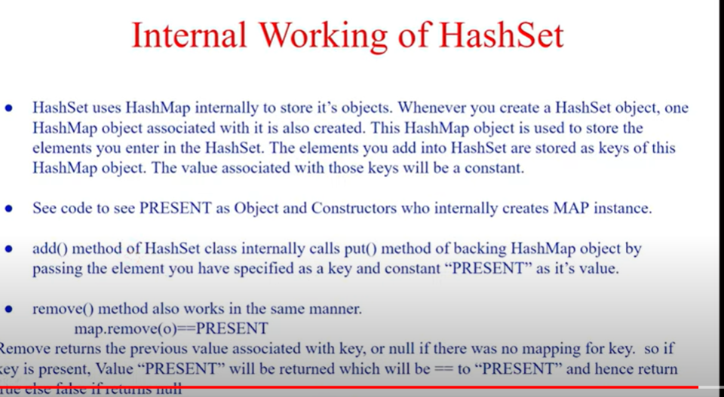

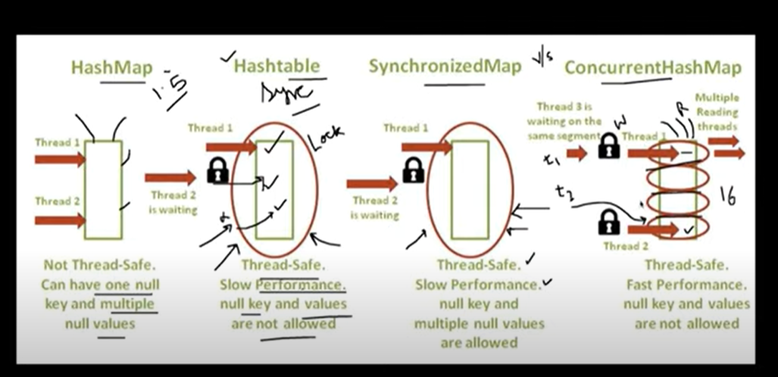

In concurrent hashmap ,lock is applied at segment level and in lock condition write/update operation is blocked.

Convert hashmap to synchronized map and syntax of ConcurrenthashMap

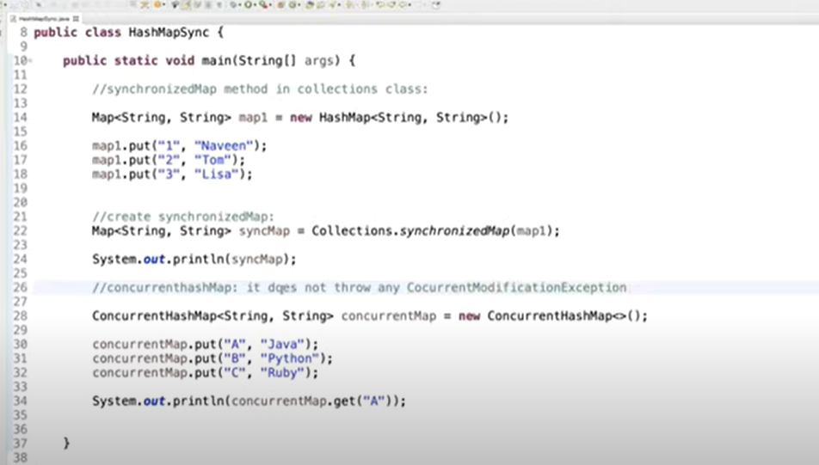

Equals and hashcode method

Shallow comparison

In shallow comparison, we compare references of an object. In the below example, since the reference of the object is the same, it returns true.

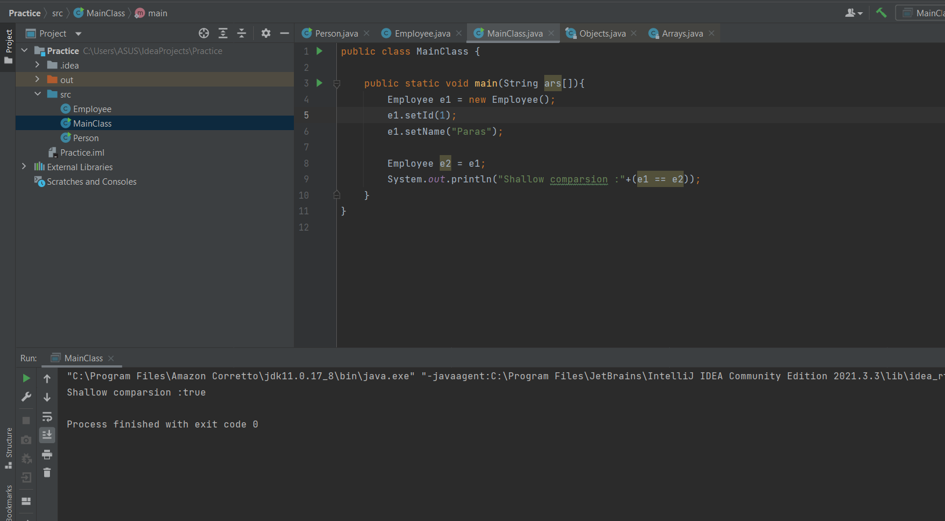

The below example returns false, since reference of object is different.

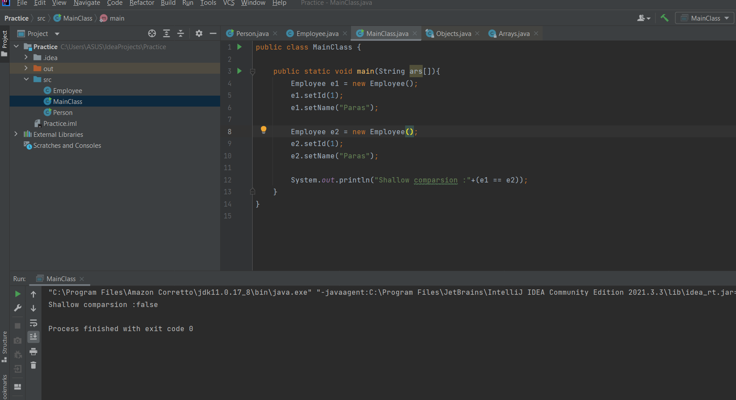

Deep Comparison

In deep comparison, the internal details of an object are compared.

In the below example, equals method was not implemented in the Employee class.

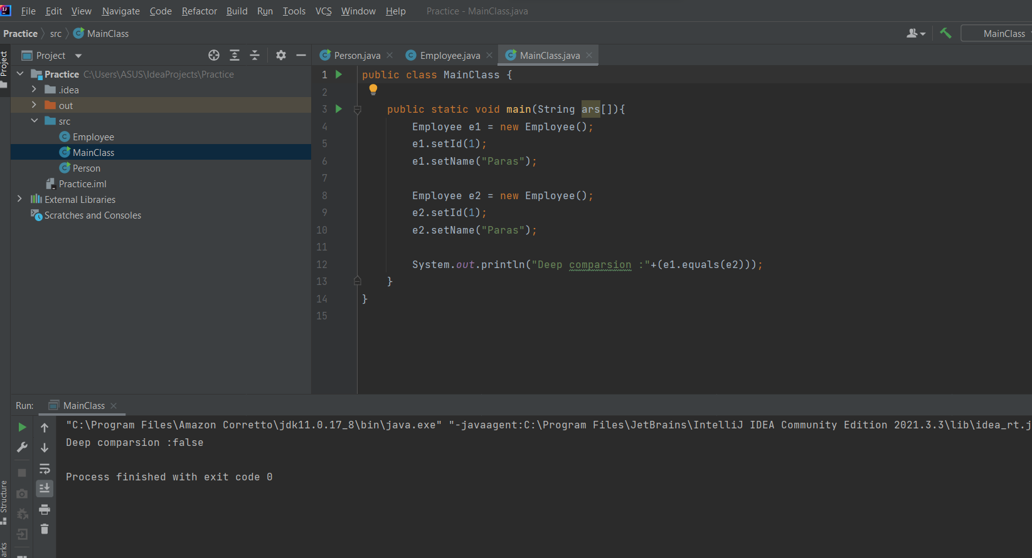

For deep comparison, we need to implement the equals method for that class.

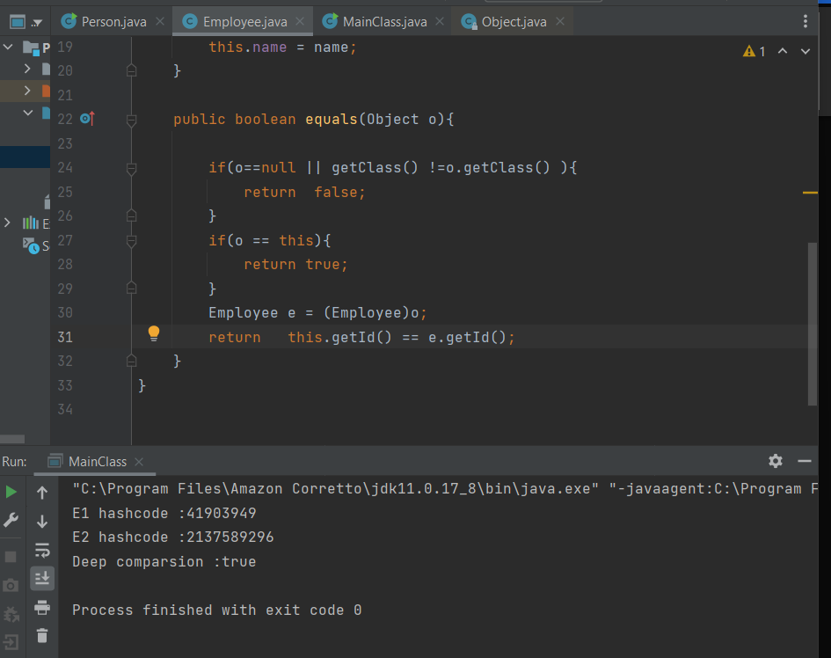

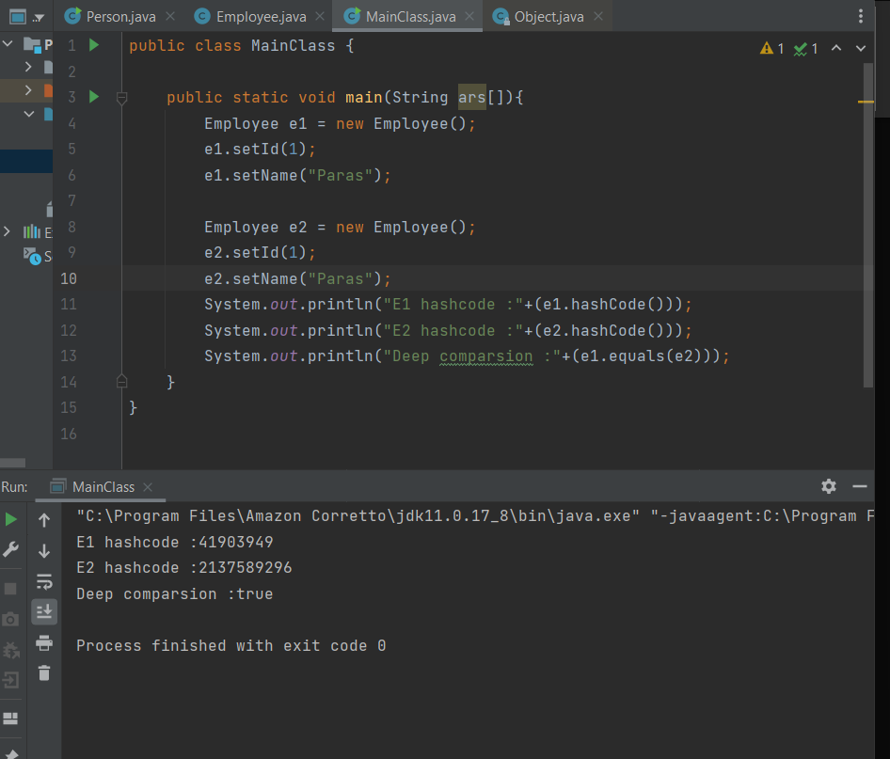

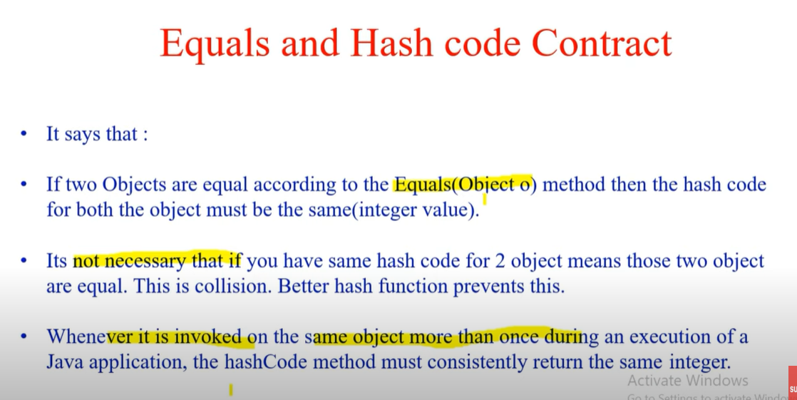

Why it is important to override hashcode function?

You must override hashCode() in every class that overrides equals(). Failure to do so will result in a violation of the general contract for Object.hashCode(), which will prevent your class from functioning properly in conjunction with all hash-based collections, including HashMap, HashSet, and Hashtable.

If only equals is overriden, then when you call myMap.put(first,someValue) first will hash to some bucket and when you call myMap.put(second,someOtherValue) it will hash to some other bucket (as they have a different hashCode). So, although they are equal, as they don't hash to the same bucket, the map can't realize it and both of them stay in the map.

The most commonly generated hashcode of an object is a prime number.

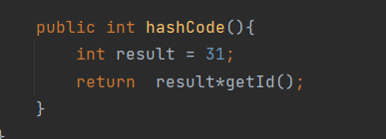

This is a simple implementation of hashCode() method. There may be different implementations of it

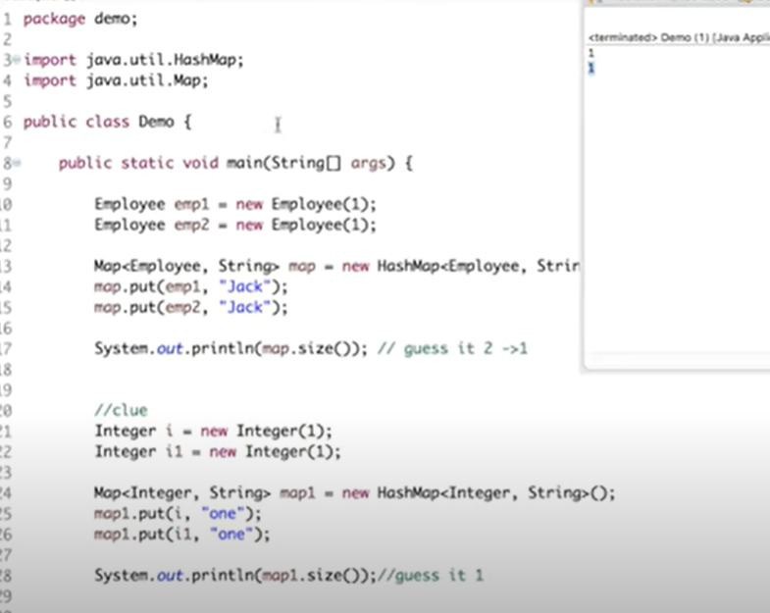

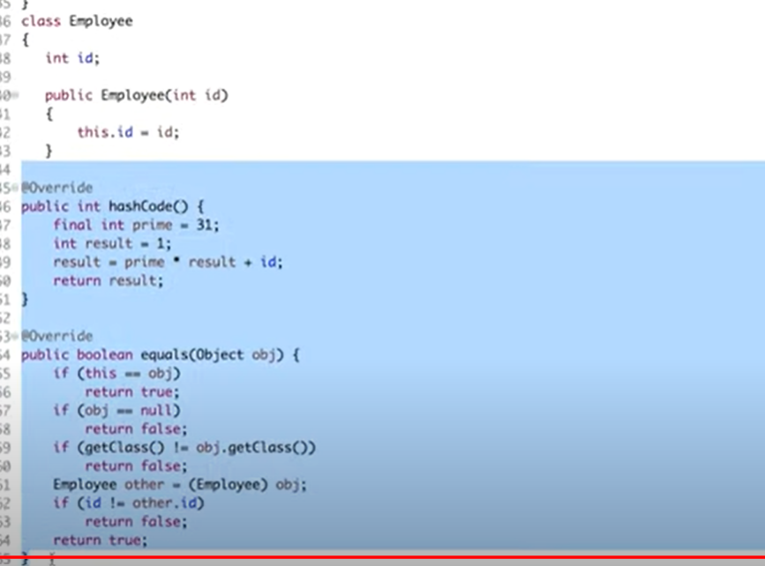

**STATIC**

Static block is executed first then main method is called. It is called when class is loaded in jvm. Static block, variables, methods does not belong to any object they are common to every object. If there are multiple static blocks then it will first go to all the static block then it will go to main.

Since static is common to all objects so static methods cannot be overridden, if there is any change to be made then it is made in the original function.

If there is a static method m1 in a parent class and it is overridden in child class, then if we call that method by the following way:

Parent p = new Child();

p.m1() // parent class implementation is called

We don’t add any specific dependencies for JUnit in spring boot, it is included in the spring boot starter test.

A static variable is a variable that is shared with all the objects of the class. If any single object changes the value of a static variable, then its value changes and it will be reflected for all the objects.

Static variables can be accessed with the class Name and with the objects as well.

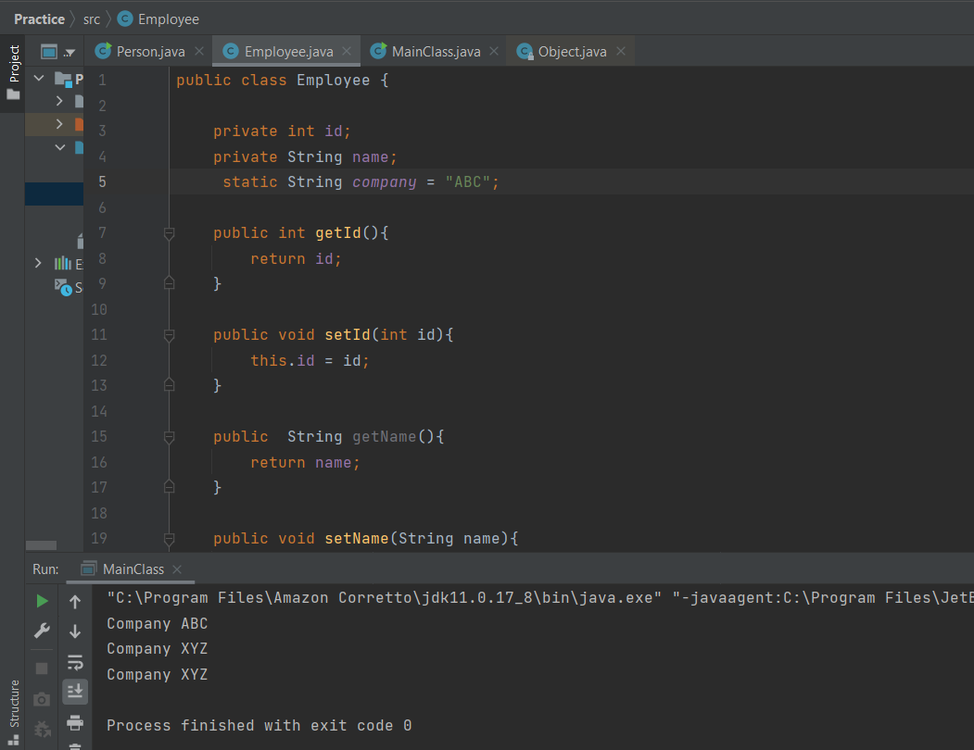

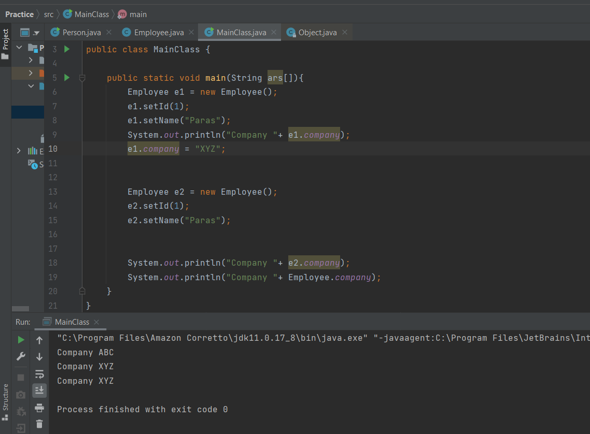

**Static variables are class variables, we cannot declare local variables inside a method as static.**

**Marker Interface**

A marker interface is an [interface](https://www.baeldung.com/java-interfaces) that has no methods or constants insideit. It provides run-time type information about objects, so the compiler and JVM have additional information about the object.

A marker interface is also called a tagging interface.

Let's take the example of the [Cloneable interface](https://www.baeldung.com/java-deep-copy). If we try to clone an object that doesn't implement this interface, the JVM throws a CloneNotSupportedException. Hence, the Cloneable marker interface is an indicator to the JVM that we can call the Object.clone() method.

In the same way, when calling the ObjectOutputStream.writeObject() method, the JVM checks if the object implements the Serializable marker interface. When it's not the case, a NotSerializableException is thrown. Therefore, the object isn't serialized to the output stream.

Let's create our own marker interface.

For example, we could create a marker that indicates whether an object can be removed from the database:

**public** **interface** **Deletable** {

}

In order to delete an entity from the database, the object representing this entity has to implement our Deletable marker interface:

**public** **class** **Entity** **implements** **Deletable** {

// implementation details

}

Let's say that we have a DAO object with a method for removing entities from the database. We can write our *delete()* method so that **only objects implementing our marker interface** can be deleted:

**public** **class** **ShapeDao** {

// other dao methods

**public** **boolean** **delete**(Object object) {

**if** (!(object **instanceof** Deletable)) {

**return** false;

}

// delete implementation details

**return** true;

}

}

**As we can see,** we are giving an indication to the JVM, about the runtime behavior of our objects.**If the object implements our marker interface, it can be deleted from the database.**

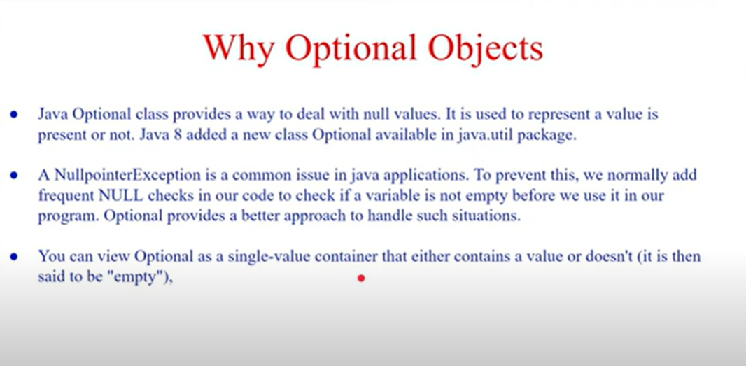

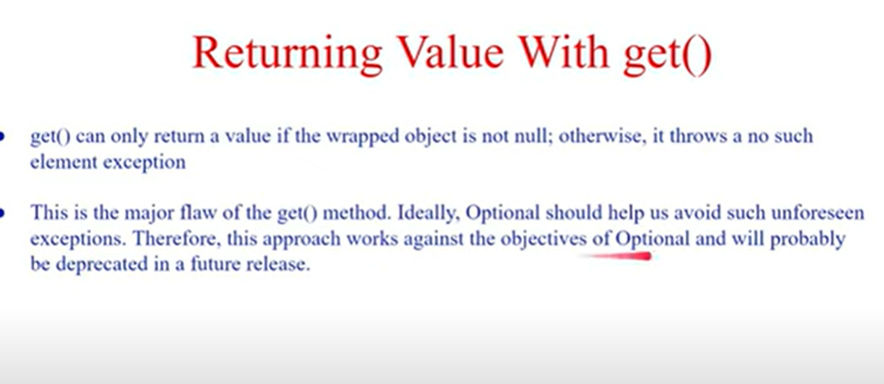

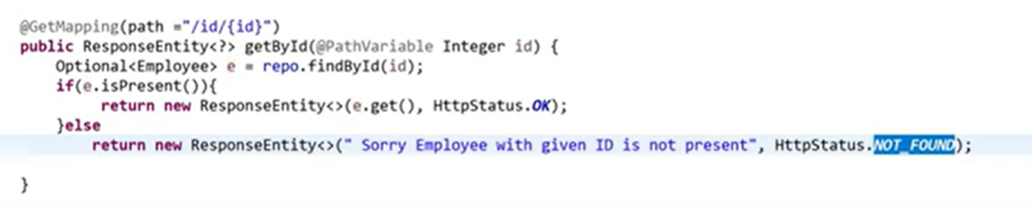

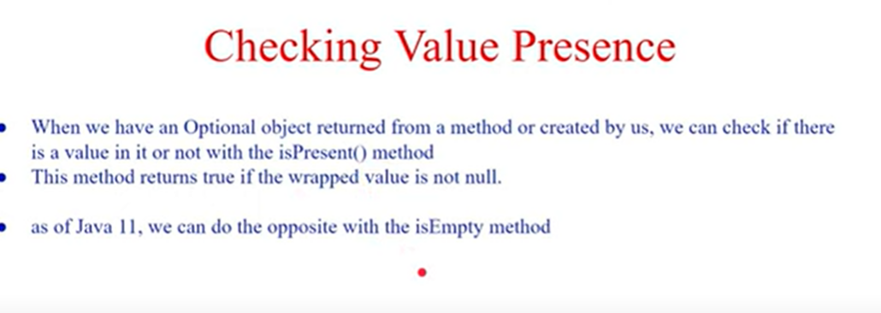

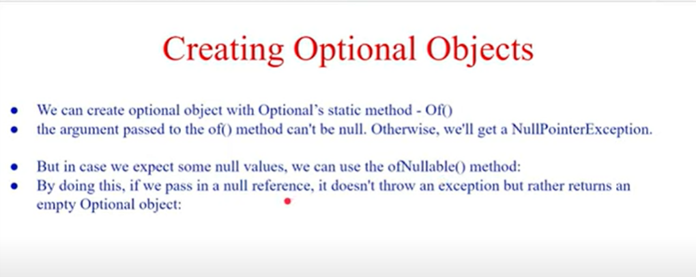

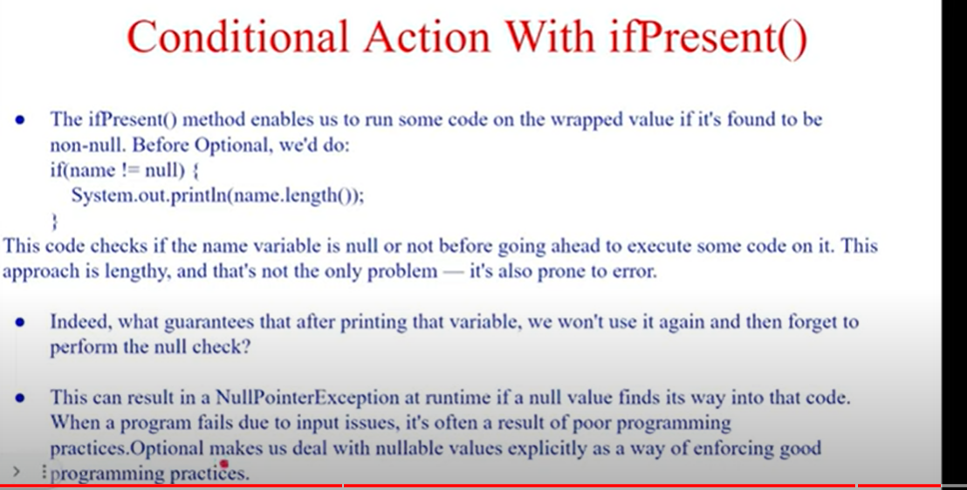

 The important methods present in the Object class:  
  
a. **clone():** this method is used to create a clone of the object  
b. **equals():** this method is used to check whether objects are equal.  
c. **hashCode():** this method returns the hash value of the object.  
d. **toString():** this method returns the String representation of the given object.  
e. **wait():**  causes the current method to wait until another thread calls notify() or notifyAll() method.  
f. **notify():** wakes up the single thread waiting for this object's monitor.  
g. **notifyAll():** wakes up all the threads, waiting for this object's monitor.  
h. **finalize():** this method is invoked by garbage collector just before the object is garbage collected.

Difference between fail safe and fail first iterator

<https://javahungry.blogspot.com/2014/04/fail-fast-iterator-vs-fail-safe-iterator-difference-with-example-in-java.html>

Access Modifier in java

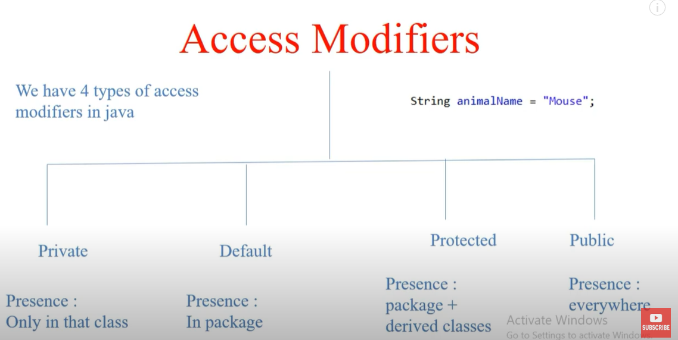

We cannot restrict the visibility of a derived method. We may increase it’s visibility but cannot restrict it. For example,

There is a parent class with method m1, there is a child class that extends the parent class. The method m1 in the parent class has an access modifier public, so in the child class, we cannot change it to private, default, or protected i.e we cannot decrease its visibility.

If method m1 is protected, then in the child class we may increase its visibility to the public.

Polymorphism

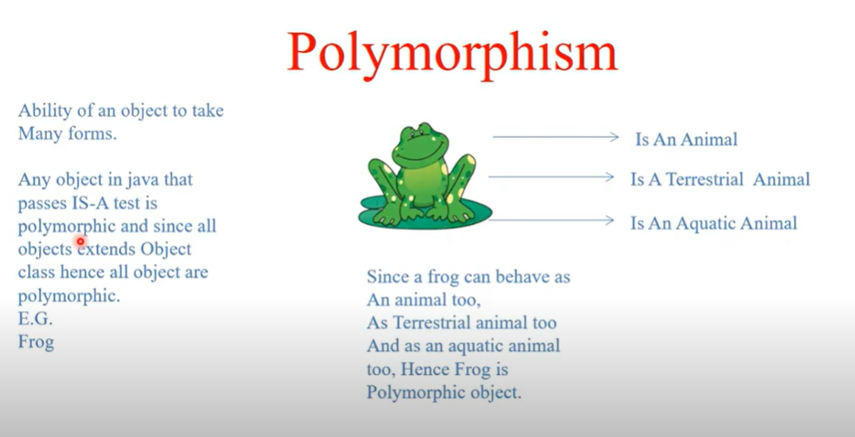

IS-A test means inheritance test

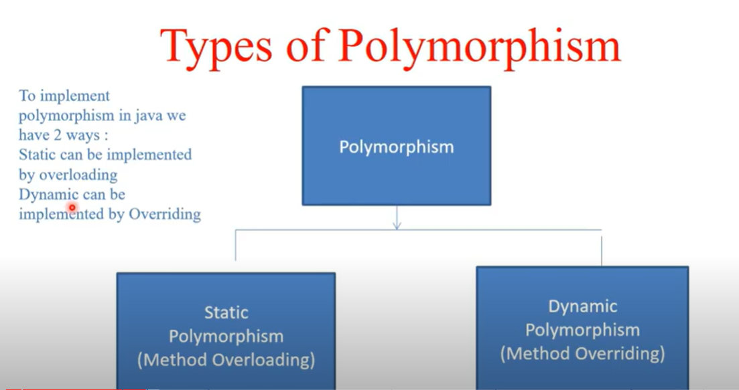

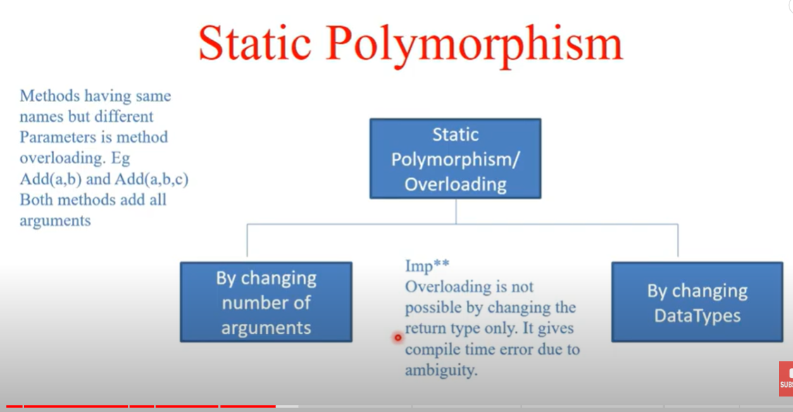

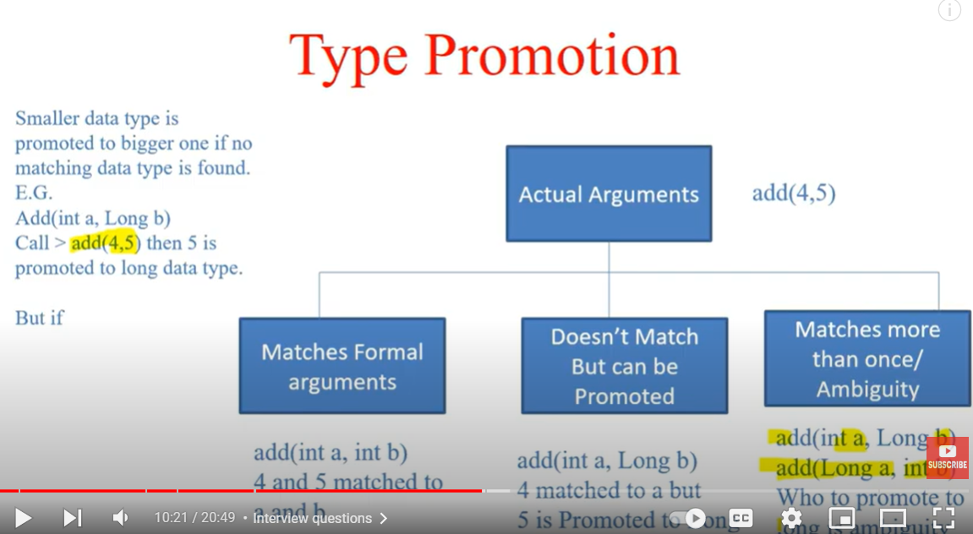

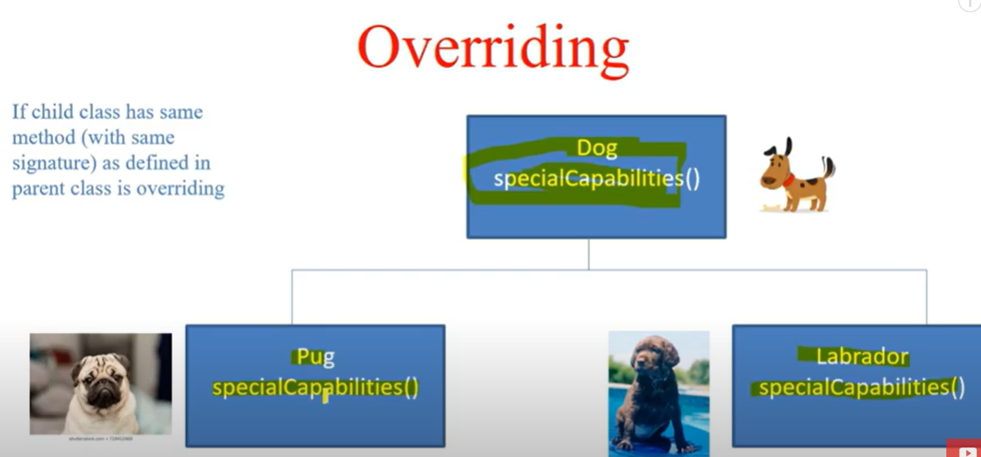

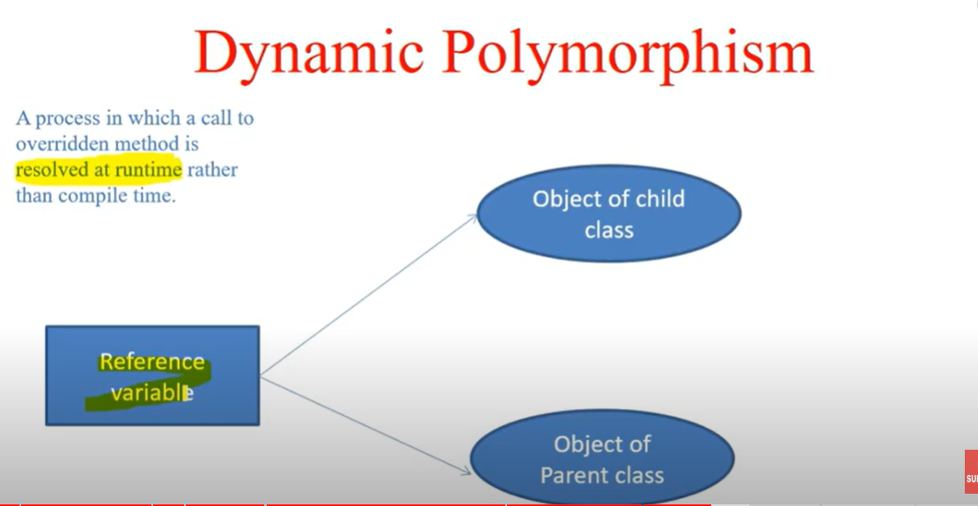

At run-time, it depends on the type of the object being referred to (not the type of the reference variable) that determines which version of an overridden method will be executed.

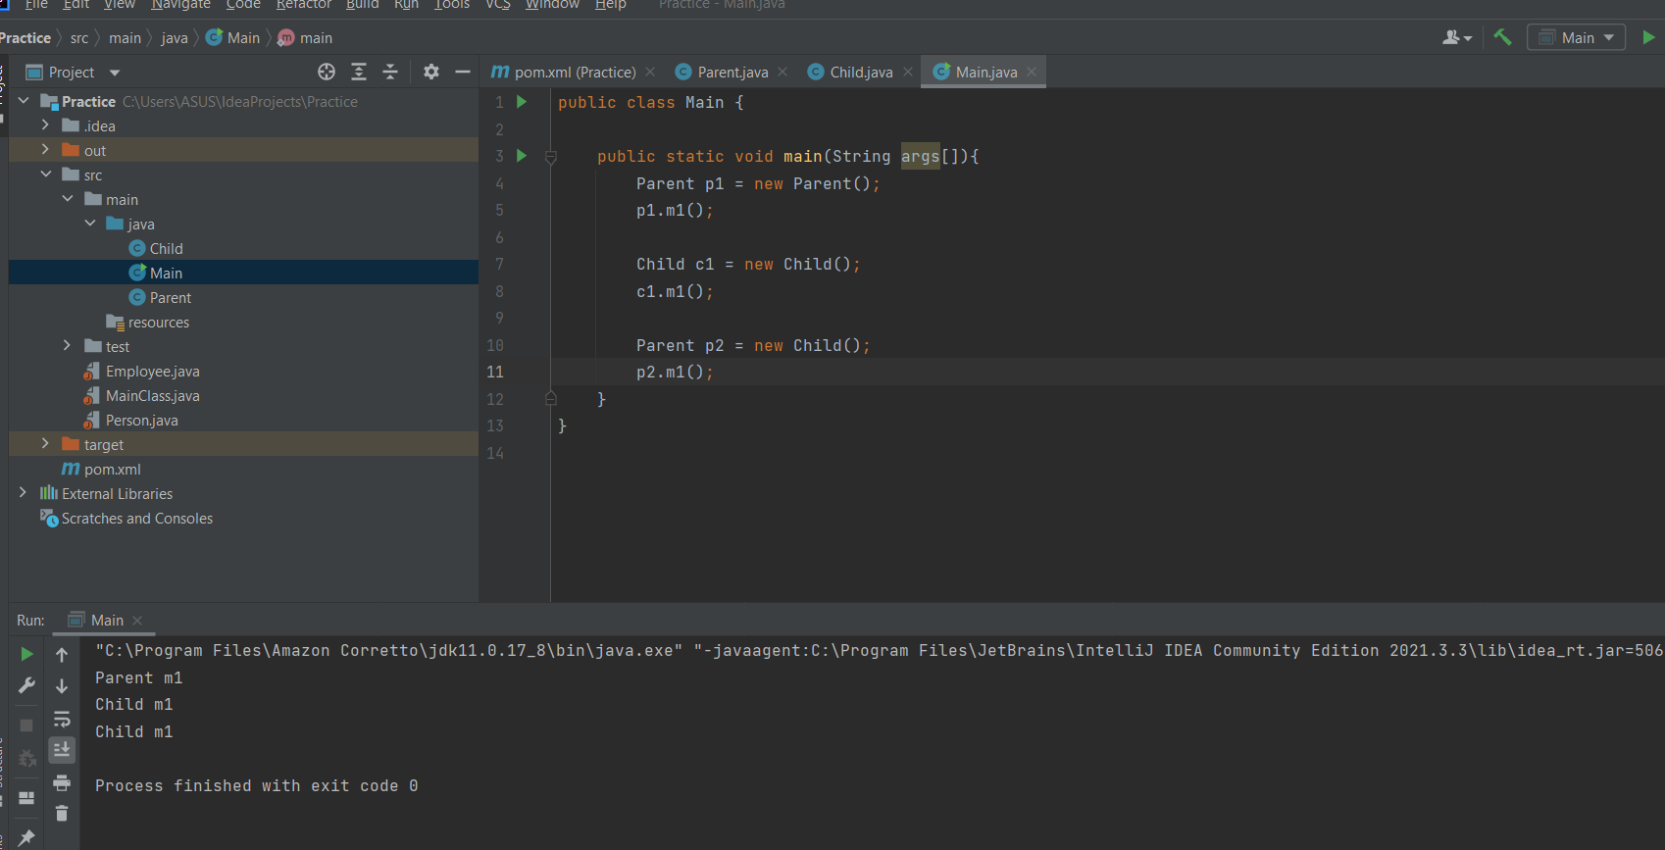

In case m1 method is static then behavior is different, static method resolution is always based on the Reference type.

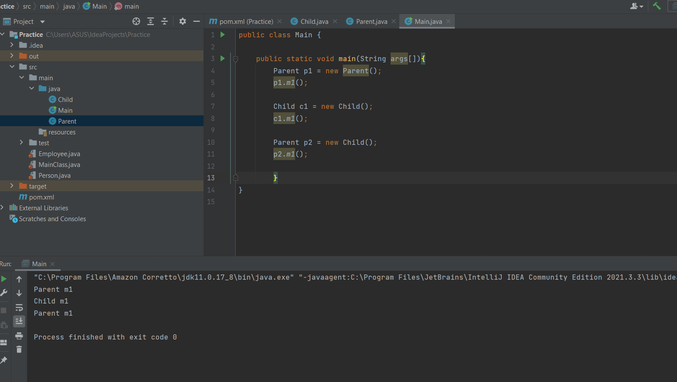

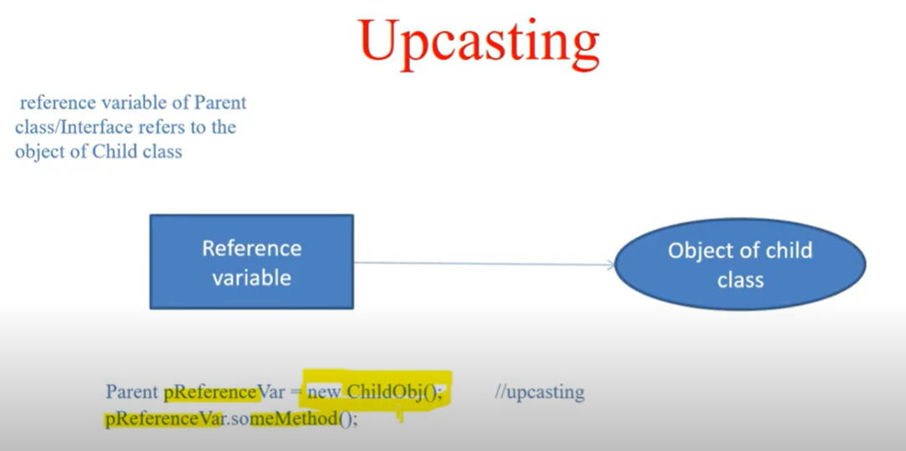

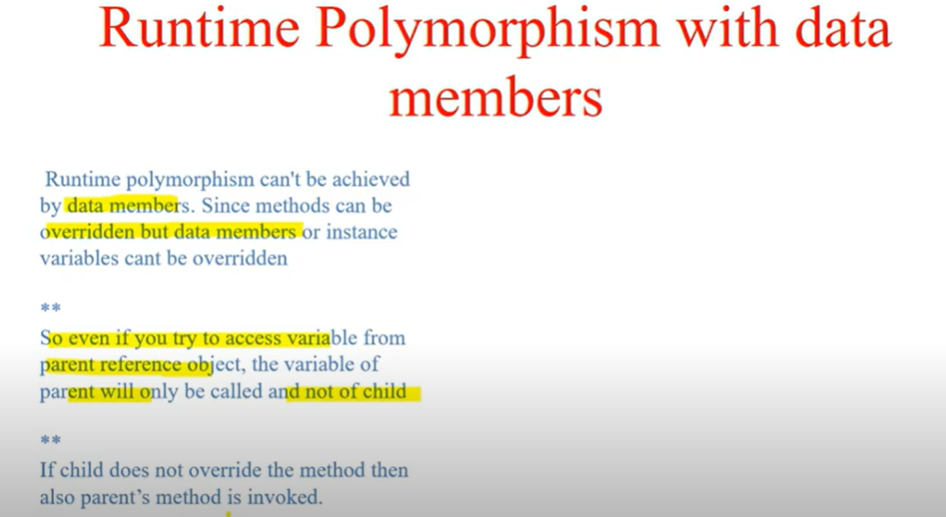

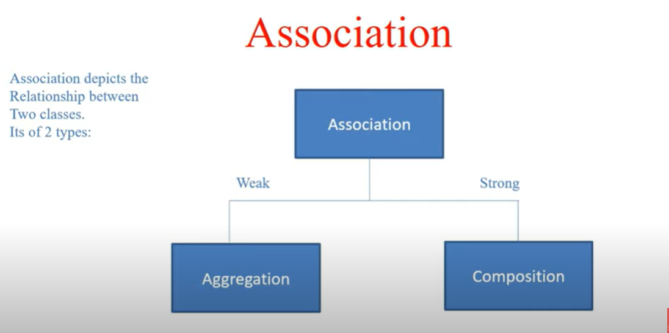

Aggregation means a weak association between two objects.

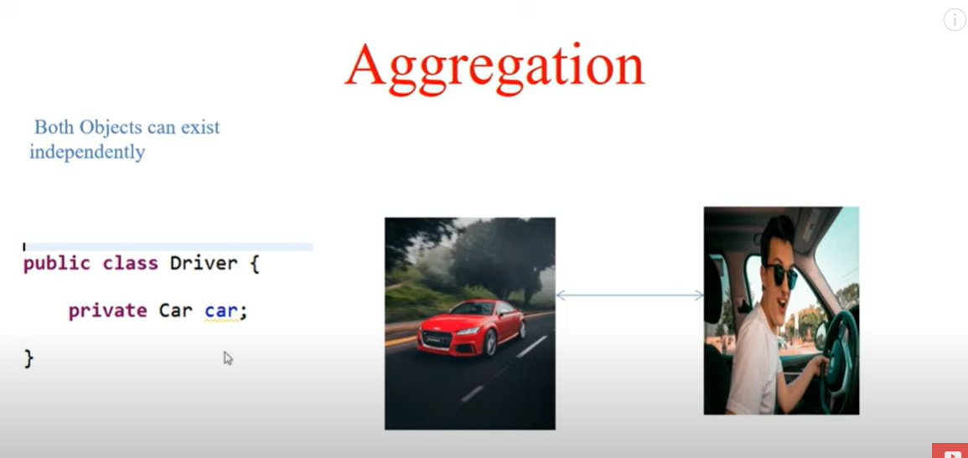

Composition means a strong association between two objects.

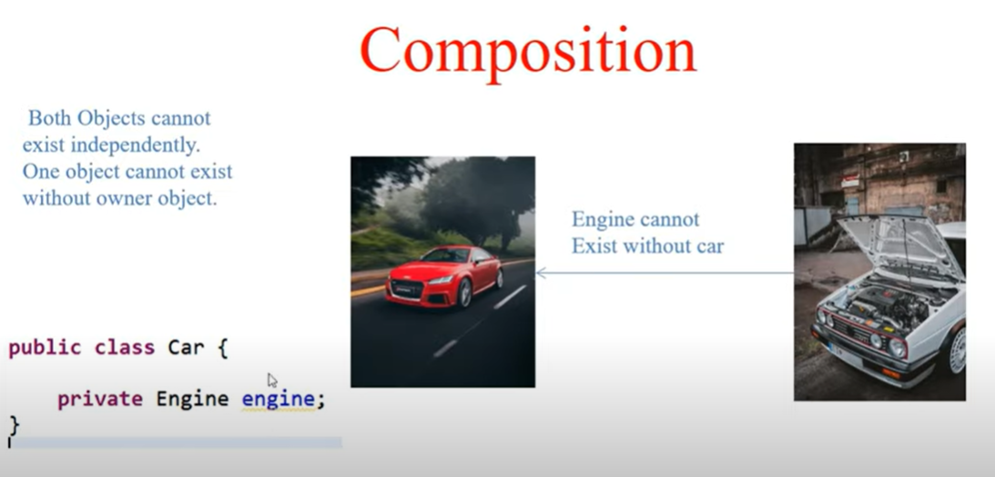

Covariant return type

The return type of an overridden method can only be same as that of parent class or it’s subclass.

For example – there are 3 classes – GrandParent, Parent, and Child.

If a method of a Parent Class (which has a return type as Parent ) is overridden in child class , then it’s return type can be only of Child or Parent.

<https://www.geeksforgeeks.org/create-immutable-class-java/>

<https://en.proft.me/2013/11/24/advantages-and-disadvantages-immutable-objects-jav/>

